

**A PROJECT REPORT**

**ON**

**HUMAN RESOURCE MANAGEMENT SYSTEM**

## Submitted By:

#### MD. ASIF HUSSAIN (ROLL NO.: 17DCS032) MD. ATIF HUSSAIN (ROLL NO.: 17DCS033) MD. TASHHIRUL ISLAM (ROLL NO.: 17DCS035)

**In the partial Fulfilment of**

**Diploma in Computer Engineering**

**Jamia Millia Islamia**

#### Under the supervision of

**Mr. Mohd. Arif**

#### Supervisor, Computer Engineering

**UNIVERSITY POLYTECHNIC**

## Faculty of Engineering & Technology Jamia Millia Islamia

#### New Delhi June 2020



Date: 15th June 2020

# CERTIFICATE

This is to certify that the project entitled **“HUMAN RESOURCE MANAGEMENT SYSTEM”** is being carried by Diploma Computer Engineering students for the award of the Diploma in Computer Engineering (Day) course. They have worked under my guidance and supervision and have fulfilled all the requirements for the submission.

#### MD. ASIF HUSSAIN (ROLL NO.: 17DCS032)

**MD. ATIF HUSSAIN (ROLL NO.: 17DCS033)**

**MD. TASHHIRUL ISLAM (ROLL NO.: 17DCS035)**

Mr. Mohd. Arif (Supervisor)

#### Approved by

Sunil Dr. Mumtaz Ahmad

(Section In-charge) (Acting Principal)

Computer Engineering Section University Polytechnic

# ACKNOWLEDGMENTS

We express our deep sense of respect and our gratitude to our supervisor Mr. Mohd. Arif. He created a friendly atmosphere, enlightened us with great ideas and patiently guided us. It was really a lifetime experience for us to work with him, and we would not be able to finish our work without his guidance, support and direction. He is epitome of knowledge and wisdom with his practical work for our chosen project problem, with his outstanding vision, crystal clear thought process and razor sharp analytical approach, he had evaluated our work with sheer pace and provided invaluable inputs for further work. We will be indebted throughout our life for his guidance and support.

We extend our thanks to other faculty members and non-teaching staff of University Polytechnic for providing all kind of support.

Place: New Delhi Date: 15th June 2020

MD. ASIF HUSSAIN (ROLL NO.: 17DCS032)

MD. ATIF HUSSAIN (ROLL NO.: 17DCS033) MD. TASHHIRUL ISLAM (ROLL NO.: 17DCS035)

# ABSTRACT

Human resource management (HRM) is the strategic and coherent approach to the management of an organization's most valued assets - the people working there who individually and collectively contribute to the achievement of the objectives of the business. The terms "human resource management" and "human resources" (HR) have largely replaced the term "personnel management" as a description of the processes involved in managing people in organizations. Human Resource management is evolving rapidly. Human resource management is both an academic theory and a business practice that addresses the theoretical and practical techniques of managing a workforce.

Human Resource plays a vital role for the existence and survival of any organization. The success or the failure depends on the perception, attitudes, values of the employees, which they have about their organization. Furthermore, it also depends upon the recruitment, selection training and development program carried out in the organization. Today organizations are existing in a stiff competition and the organizations are facing problems in the areas of technological advancement, shortage of resources power, energy etc.

When these provisions are taken care the health of the employees are maintained i.e. both physical and psychological aspects are given importance. The welfare benefits make the employee to feel that his organization is giving much importance to the employees and in turn loyalty and commitment increases. When these are developed the satisfaction towards the work is also very high. These are the factors which will have an immediate effect upon the employees. In order to achieve the production as per the desired standards we have to motivate the employees through performance appraisal schemes and by the training programmers. So these activates are very essential for the smooth functioning of the organization. Various research findings in the fields of psychology, behavioral sciences

had concluded that training, performance appraisal, welfare measures are the key components in the success of any organization. In order to take care of these measures Human resource Management department are established. Because HRM is a proactive measure carried out in the organization. It helps to achieve productivity and profitability.

Human Resource management is an often-underestimated task in work environments. However, it is adequate and conscientious HR management that will establish and retain a qualified, well-cooperating workforce and therefore, ultimately, an increase of organizational growth, efficiency, and profitability. Needs for HR practice are changing rapidly in the 21st Century as a new context emerges from rapid political, technological, market and demographic changes. The challenge for both HR leaders and general managers is to build capabilities that ensure the successful execution of business strategy. The next generation of senior HR professionals will need to think in new ways, take diverse perspectives and lead their organization with confidence. The simple message embedded in all of the above is that people need to be kept satisfied in order to perform well in a workplace. Managers should try to treat all workers correctly and never make the mistake of playing workers against each other; while, at the same time, they should also be aware that the ways in which workers get motivated vary richly. A good rapport between departmental management and HR is therefore recommended, although, unfortunately, it is not implemented too often yet.

|  |  |
| --- | --- |
| **TABLE OF CONTENTS** | |
| **DESCRIPTION** | **PAGE NUMBER(REF)** |
| CERTIFICATE | i |

ACKNOWLEDGEMENTS ii

ABSTRACT iii

LIST OF FIGURES iv

LIST OF TABLES v

LIST OF PICTURES vi

1. INTRODUCTION

1.1 What our Project………………………………… 1

1.1.1 Main Objective of project……………………….. 1

* 1. Proposal of project (Why)………………………. 2
     1. Limitations of Current System…………………... 2
     2. Proposed System and its Features……………….. 3

1.3 Motivation………………………………………. 3

1.4 Contribution……………………………………... 4

1.5 Background……………………………………… 4

1. FUNCTION OF HUMAN MANAGEMENT SYSTEM

2.1 Function…………………………………………. 5-6

2.1.1 Payroll Module………………………………… 6

2.1.2 Work Time…………………………………….. 6

* + 1. Benefits Administration Module……………… 6
    2. HR Management Module……………………… 6-7

2.1.5 Recruiting……………………………………… 7

2.1.6 Training Module………………………………. 7-8

2.1.7 Employee Self-Service Module……………….. 8

1. OBJECTIVES

3.1 Objective…………………………………………. 9

3.2 Project Objectives………………………………………….. 9-10

3.3 Advantages………………………………………. 10

3.4 Disadvantages……………………………………. 10

1. SYSTEM DESCRIPTION

4.1 Admin…………………………………………… 11

4.1.1 Login……………………………………………... 11

4.1.1.1 Dashboard……………………………………. 11

4.1.1.2 Attendance……………………………………. 11

4.1.1.3 Employee……………………………………... 11

4.1.1.4 Positions………………………………………. 11

4.1.1.5 Payroll………………………………………… 11

4.1.1.6 Deductions……………………………………. 11

4.2 User………………………………………………. 12

4.2.1 User Id…………………………………………. 12

4.2.1.1 Time-in……………………………………… 12

4.2.1.2 Time-out…………………………………….. 12

4.2.2 Schedules……………………………………… 12

* 1. Working of Project……………………………… 12
     1. Schematic diagram……………………………. 12
     2. Employee Details……………………………… 13

4.3.3 Payroll…………………………………………. 13

4.3.4 Training………………………………………... 13-14

4.3.5 Performance…………………………………... 15

1. SOFTWARE REQUIREMENTS SPECIFICATION
   1. General Description 16
      1. Problem Statement 16
         1. File Lost 16
         2. Space Consuming 16
         3. Cost Consuming 16
      2. System Objective 17
   2. System Requirements 18
      1. Non-functional Requirements………………… 18
      2. Functional Requirements……………………... 19
         1. Description of Features………………. 19
         2. Register New User 19
   3. Hardware Specification for Client 20
   4. Software Specification for Server 20-21
      1. Project Category 21
      2. Tools & Language Used 21
   5. Process Model 21-25
      1. System Analysis and Design 21-22
         1. Requirements 22-23
         2. System and Software Design 23
         3. Analysis 23-24
         4. Requirement Analysis 24
         5. Implementation and Unit Testing 25
         6. Integrated and System Testing 25
         7. Operation and Maintenance 25
2. REQUIREMENTS SPECIFICATION & FEASIBILITY STUDY
   1. Requirements Specification 26
      1. Performance Requirements 26
      2. Functional Requirements 26
   2. Logical Data Flow Diagram 27
   3. Feasibility Study 28
      1. Economic Feasibility 28
      2. Technical Feasibility 28
      3. Legal Feasibility 28
      4. Operational feasibility 28
      5. Time feasibility 28
   4. System Hierarchy 29
   5. Structural System Analysis 30-34
      1. System Flow Chart 30
      2. Use case Diagram for Admin 31
      3. Use case diagram for organization 32
      4. Use case diagram for organization 33
      5. Use case Diagram for Attendance and salary 34
   6. Process Design 35-42
      1. Symbols Used in Data Flow Diagram 35
      2. Data Flow Diagram 36-40
         1. Context 36
         2. Level 1 DFD 37-38
         3. Level 2 DFD 39-40
      3. Entity Relationship Diagram 41
      4. Gantt Chart 42
   7. Database Design 43-46
   8. Output Design 46
3. SOFTWARE TOOL USED
   1. Front End 47-49
      1. HTML5 47
      2. CSS 48
      3. Bootstrap 48
      4. JavaScript 49
      5. Ajax 49
      6. JSON 49
      7. jQuery 49
   2. Back End 50

8.2.1 Php 50-51

1. INPUT & OUTPUT CODING OF PROJECT
   1. Index.php 52-53

9.2 Home.php................................................................ 54-64

* 1. Attendance 65-69
  2. Employee.php 70-76
  3. Overtime.php 77-83
  4. Cashadvance.php 83-88
  5. Schedules.php 89-93
  6. Deduction 94-97
  7. Positions 98-101
  8. Sql Query 102-115
  9. Database Connectivity 116-119

1. **CONCLUSION**
   1. Conclusion 120
   2. Future work 120

# REFERENCES 121

**LIST OF FIGURES**

## FIGURE TITLE PAGE NUMBER

1. Overview of Human Resource Management Systems……………………………………… 12
2. Employee Details……………………………. 13

3. Payroll System………………………………. 14

4. Training……………………………………… 14

5. Performance…………………………………. 15

6. Waterfall Model……………………………… 22

1. System Description………………………….. 24
2. Operation & Maintenance…………………… 25
3. Logical Data Flow Diagram…………………. 27
4. System Hierarchy……………………………. 29
5. System Flow Chart………………………….. 30
6. Use case of Admin Login…………………… 31
7. Use case diagram for organization…………. 32
8. Use case for organization…………………….. 33
9. Use case for Attendance & salary………….... 34
10. Symbol used In DFD…………………………. 35

17. Context Diagram………………………….. 36

1. Level 1 DFD for Admin Module…………… 37
2. Level 1 DFD for user Module……………… 38
3. Level 2 DFD for Employee Detail Maintenance Module39
4. Level 2 DFD for Salary Management Module…… 40

22. ER Diagram…………………………………… 41

23. Gantt chart……………………………………. 42

**LIST OF TABLES**

## TABLES TITLE PAGE NUMBER

1. Hardware……………………………………… 20

2. Tools & Language…………………………… 21

3. Admin Login………………………………… 43

4. Attendance…………………………………… 44

5. Cash Advance………………………………… 44

6. Deductions…………………………………… 44

7. Employees…………………………………… 45

8. Overtime…………………………………… 45

9. Position……………………………………. 46

10. Schedules…………………………………... 46

**LIST OF PICTURES**

## PICTURES TITLE PAGE NUMBER

1. **Admin Login Page** …………………………… 53

2. Home Page……..…………………………… 64

3. Attendance Page…………………………….. 69

4. Employee Page……………………………… 76

5. Overtime Page……………………………… 83

6. Cash advance Page………………………… 88

7. Schedules Page……………………………… 93

8. Deduction Page…………………………….. 97

9. Position Page……………………………….. 101

10. Database Connectivity……………………… 116-119

**CHAPTER 1**

**INTRODUCTION**

# What Our Project?

The objective of this chapter is to discuss the introduction, motivation, contribution and outline of our project.

The project titled **“HUMAN RESOURCE MANAGEMENT SYSTEM”** is basically concerned with managing the Administrator of HUMAN RESOURCE Department in a company. A **Human Resource Management System (HRMS)**, refers to the systems and processes at the intersection between human resource management (HRM) and information technology. It merges HRM as a discipline and in particular its basic HR activities and processes with the information technology field, whereas the programming of data processing systems evolved into standardized routines and packages of enterprise resource planning (ERP) software.

## Main Objective of project

The main objective of this project is to reduce the effort of Administrator to keep the daily events such as attendance, projects, works, appointments, etc.

* This project deals with the process of identifying the employees, recording their attendance hourly and calculating their effective payable hours or days.
* This paper should maintain the records of each and every employee and their time spend in to company, which can be used for performance appraisal. Based on that transfer, removal, promotion can be done.

# Proposal of project (Why)

The basic purpose of designing this project is to get free from manual entry and record system and try to give easy and simple database management system for humans. And get free from the offline work.

* The existing system is not providing secure registration and profile management of all the users properly. This manual system gives us very less security for saving data and some data may be lost due to mismanagement.
* The paper is used to maintain efficiently the HR department schedule of any type of company. In larger organization, employees are large. At that time this paper is useful and helpful. HR Management system is not only becomes a desire of the company but it becomes the need of the company. The Administrator gets into the system using admin name and a password.

## Limitations of Current System

There were problems related to current system such as employee details storage problem, maintain privacy, cost and budget, etc.

* **Employee Privacy:** Your employee entrust you with personal information. Everything from Social Security numbers to private health information and marital status gets stored in HR Management System.
* **Cost:** One of the main limitation/disadvantage of HR Management System is its cost.
* **Loss of Subjectivity:** All personal data of any employee was easily leaked.
* **Difficult of Analysis:** Due to huge amount of data stored in your system it becomes difficult to analyze the data.

## Proposed System and its Features

Using today’s updated software and running technologies we have developed software which can come overcome the problems of current system.

The solutions made by proposed system are as follows:

* **Fast retrieval of data:** Response of data retrieving was improved by proposed system with high throughput.
* **Security:** personal information data of employee was secured.
* **Ease of use:** Propose system must be user-friendly.
* **Payroll:** The payroll module of HR Management System automates the payment process by gathering data of employee time and attendance, calculating various tax, etc.
* **Work Time:** The work tie gathers standardized time and work related effort.
* **Administration:** The admin module of HRMS handles all operations related to employee.

# Motivation

The Project is used to maintain efficiently the HR department schedule of any type of company. In larger organization, employees are large. At that time this paper is useful and helpful. HR Management system is not only becomes a desire of the company but it becomes the need of the company. The Administrator gets into the system using admin name and a password.

As HRM play such an important role in creating a positive workplace culture and engaging in personnel development, gaining the right qualifications and professional accreditation is essential. From that I got motivated to make this project.

# Contribution

In this project first we studies the drawback of existing system and what is the best possible way to handle large organization in computerized manner at this time. Then we have studies the different programming languages, by which we are able to develop a successful Human Resource Management System.

# Background

Previously students must approach again and again to offices for any small work in various circumstances to get details of different things. This often wastes a lot of time and we know that what is the importance of time and how it is more precious for the students and effort of the users or students. The students may not get the desired information from office staff and generally the students may be misguided or not get the right method or action by the administration. It is tedious for a student to plan a work and have it executed properly. It also creates wastage of money or time of users without any desired reasons.

So, we have automated all the management work related to the organization into a single website named as “Human Resource Management System”.

# CHAPTER 2

**FUNCTION OF HUMAN MANAGEMENT SYSTEM**

* 1. **Function**

The function of Human Resources departments is generally administrative and not common to all organizations. Organizations may have formalized selection, evaluation, and payroll processes. Efficient and effective management of "Human Capital" has progressed to an increasingly imperative and complex process. The HR function consists of tracking existing employee data which traditionally includes personal histories, skills, capabilities, accomplishments and salary. To reduce the manual workload of these administrative activities, organizations began to electronically automate many of these processes by introducing specialized Human Resource Management Systems. HR executives rely on internal or external IT professionals to develop and maintain an integrated HRMS. Before the client–server architecture evolved in the late 1980s, many HR automation processes were relegated to mainframe computers that could handle large amounts of data transactions. In consequence of the low capital investment necessary to buy or program proprietary software, these internally-developed HRMS were unlimited to organizations that possessed a large amount of capital. The advent of client–server, Application Service Provider, and Software as a Service or SaaS Human Resource Management Systems enabled increasingly higher administrative control of such systems. Currently Human Resource Management Systems encompass:

* + - Payroll
    - Work Time
    - Benefits Administration
    - HR management Information system
    - Recruiting
    - Training / Learning Management System
    - Performance Record
    - Employee Self-Service

## Payroll Module

The **payroll module** automates the pay process by gathering data on employee time and attendance, calculating various deductions and taxes, and generating periodic pay cheques and employee tax reports. Data is generally fed from the human resources and time keeping modules to calculate automatic deposit and manual cheque writing capabilities. This module can encompass all employee-related transactions as well as integrate with existing financial management systems.

## Work Time

The **work time** gathers standardized time and work related efforts. The most advanced modules provide broad flexibility in data collection methods, labor distribution capabilities and data analysis features was outdated. Cost analysis and efficiency metrics are the primary functions.

## Benefits Administration Module

The **benefits administration module** provides a system for organizations to administer and track employee participation in benefits programs. These typically encompass insurance, compensation, profit sharing and retirement.

## HR Management Module

The **HR management module** is a component covering many other HR aspects from application to retirement. The system records basic demographic and address data, selection, training and development, capabilities and skills management, compensation planning records and other related activities. Leading edge systems provide the ability to "read"

applications and enter relevant data to applicable database fields, notify employers and provide position management and position control not in use. Human resource management function involves the recruitment, placement, evaluation, compensation and development of the employees of an organization. Initially, businesses used computer based information systems to:

* Produce pay checks and payroll reports;
* Maintain personnel records;
* Pursue Talent Management.

## Recruiting

Online **recruiting** has become one of the primary methods employed by HR departments to garner potential candidates for available positions within an organization. Talent Management systems typically encompass:

* Analysing personnel usage within an organization;
* Identifying potential applicants;
* Recruiting through company-facing listings;
* Recruiting through online recruiting sites or publications that market to both recruiters and applicants.

The significant cost incurred in maintaining an organized recruitment effort, cross-posting within and across general or industry-specific job boards and maintaining a competitive exposure of availabilities has given rise to the development of a dedicated Applicant Tracking System, or 'ATS', module.

## Training Module

The **training module** provides a system for organizations to administer and track employee training and development efforts. The system, normally called a Learning Management System if a stand-alone product, allows HR to track education, qualifications and skills of the employees, as well as outlining what training courses, books, CDs, web

based learning or materials are available to develop which skills. Courses can then be offered in date specific sessions, with delegates and training resources being mapped and managed within the same system. Sophisticated LMS allow managers to approve training, budgets and calendars alongside performance management and appraisal metrics.

## Employee Self-Service Module

The **Employee Self-Service module** allows employees to query HR related data and perform some HR transactions over the system. Employees may query their attendance record from the system without asking the information from HR personnel. The module also lets supervisors approve O.T. requests from their subordinates through the system without overloading the task on HR department.

Many organizations have gone beyond the traditional functions and developed human resource management information systems, which support recruitment, selection, hiring, job placement, performance appraisals, employee benefit analysis, health, safety and security, while others integrate an outsourced Applicant Tracking System that encompasses a subset of the above.

# CHAPTER 3 OBJECTIVES

Manually it is very difficult to manage the human resource. With the help of computer it becomes easy and faster to manage the system. In this project it is the facilities to storing and managing all the information about the employee working in that company and the projects handle by the company.

## Objective

The main objective of this paper is to reduce the effort of administrator to keep the daily events such as payroll, employee performance, and employees’ details. It consists of six modules.

They are:

* + - Employee Details
    - Payroll
    - Training
    - Performance
    - Resignation
    - Resume tracking.

## Project Objectives

The objectives of this project are as follows:

* + - To manipulate the transactions with instant confirmation.
    - To save time and accuracy in work.
    - To increase efficiency of employee.
    - For fast access of data.
    - For secure and smooth running of the program.
    - For error free, effective and easy for database related works.
    - Print the payment details and other necessary constraints.
    - Disseminate the news that is related to any number of things for example for organize any program, for selling any things, lost and found information etc.

## Advantages

* + - Less efforts and error.
    - User friendly interface.
    - Fast access to database.
    - Look and Feel Environment.
    - Reduce in Time Expenditures.
    - Easy access to the data
    - The new system is more user-friendly, reliable and flexible.
    - Data alteration is easy.
    - Maintenance of the project is easy.
    - Reduced manual work.
    - Timely Report generation.

## Disadvantages

* + - Administration may require daily update their HMS.
    - It increases the cost because of new setting up a new system or updating the existing one.
    - In addition, it requires to hire or train an IT support team to handle this online HMS
    - It decreases the employments opportunities in the employee office.

# CHAPTER 4 SYSTEM DESCRIPTION

It is a transposition for manually Human Management System which depends on paper work. It will provide an advanced facility that sort-out the problems of the company immediately.

# Admin

* + 1. **Login –** This module is used for admin login.
       1. **Dashboard –** Admin dashboard related total employee details.
          - Late today
          - On time today
          - Total Employee
          - Attendance percentage
          - Monthly attendance report using bar graph
       2. **Attendance** – It shows the total attendance of employee.
       3. **Employee** – This shows total employee details.
          - Employee List
          - Overtime
          - Cash Advanced
          - Schedules
       4. **Positions** – It shows the position of employee.
       5. **Payroll** – It calculate the total salary
       6. **Deductions** – It reduce the salary.

# User

* + 1. **User Id –** User through this panel
       1. **Time-in –** Time will be noted when user enters.
       2. **Time-out –** Time will be noted when user exit.
    2. **Schedules –** It shows the employee working time.

# Working of Project

## Schematic diagram showing the proposed mechanism



Attendance

Employees

Positions

Home

Deductions

Payroll

Schedule

**Fig. 1: Overview of Human Resource Management Systems**

## Employee Details

Employee Details module is used to maintain the employees’ details such as adding new employee, modifying the existing employee and deleting the existing employee. When a new employee is selected from the resume tracking, all the details are to be entered and maintained in the database.



Search

Login

Employee

Details

#### Fig. 2: Employee Details

The employee details contain three kind of information.

1. Personal Information
2. Contact Information
3. Employee Status
   * In the personal information, it consists of the information about the employee name, employee id, nationality, etc.
   * In the contact information, it consists of the information about the employee address, phone numbers, etc.
   * In the employee status, it consists of the information about the status of the employee, supervisor name, department, etc.

## Payroll

In the payroll module, it consists of the information about the employee salary details such as basic pay, allowances, deductions and calculate the gross pay and net pay from the given allowances and deductions.



Search

Login

Payroll

**Fig. 3: Payroll System**

All the employees’ pay details are maintained by the HR manager. The main function of this payroll module is to maintain the employee pay information.

## Training

In this training module, it consists of the employees’ schedule about the training conducted in the organization for the particular employee. The employees’ previous training experience will be maintained in the database.



Search

Login

Training

**Fig. 4: Training System**

In the module contains the information about the employees who are in the Training and who are finished the training. These details are to be used in the payroll calculation.

## Performance

This performance module contains information about the employee’s current position in the organization. This module has the information such as employee name, employee ID, Division, work group, evaluation date, evaluator, and evaluation period.



Search

Login

Performance

**Fig 5: Performance of Employees Position**

This module is used to monitor the employees, their work performance and the involvement of them in the organization.

# CHAPTER 5

**SOFTWARE REQUIREMENTS SPECIFICATION (SRS)**

# General Description

Human Management System is a computerized system which helps user to manage the daily activity in electronics format. It reduces the risk of paper work such as file lost, file damaged and time consuming.

## Problem Statement

The problem occurred before having computerized system includes: -

* + - 1. **File Lost:** When computerized system is not implemented file is always lost because of human environment. Sometimes due to some human errors there may be a loss of records.

File damaged when a computerized system is not their file is always due to some accident like spilling of water by some member on file accidently. Besides some natural disaster like floods or fires may also damage the files.

* + - 1. **Space Consuming:** After the number of records becomes large the space for physical storage of file and records also increase if no Computerized system is implemented.
      2. **Cost Consuming:** As there is no computerized system then to add each record paper will be needed this will increase the cost for the management of employee.

## System Objective

#### Improvement in control and performance:

The system is developed to cope up with the current issues and problems of hostels. The system can add user, validate user is also bug free.

#### Save Cost:

After computerized system is implemented less human force will be required to maintain the hostel thus reducing the overall cost.

#### Save Time:

User can sort out anything in few clicks of mouse and few search keyboards thus saving his valuable time.

# System Requirements

## Non-functional Requirements

##### *Efficiency requirement:*

When Hostel Management System will be implemented staff and user will easily access website and success transaction will be very faster.

##### *Reliability requirement:*

The system should accurately perform user registration, user validation and search a successful transaction.

##### *Usability requirement:*

This system is designed for a user-friendly environment so that user and staff of hostel can perform the various tasks easily and in an effective way.

##### *Implementation requirement:*

In implementation whole system it uses html in front end with JavaScript, PHP as server-side scripting language which will be used for database connectivity and the back end i.e. the database part is developed using SQL.

##### *Delivery requirement:*

The whole system is expected to be delivered in six months of time with a weekly evaluation by the project guide.

## Functional Requirements

#### Description of Features

This feature used by the user tlogin into system. They are required to enter user id and password before they can enter the system. The user id and password will be verified and if invalid id is there user is not allowed to enter the system.

Functional Requirement:

* User id is provided when they register
* The system must only allow user with valid id and password to enter the system.
* The system performs authorization process which decides what user level can access to.
* The user must be able to logout after they finished using system.

#### Register New User

Description of Feature

This feature can be performed by all users to register new user to create account.

Functional Requirement:

* + - * + System must be able to verify information
        + System must be able to delete information if information is wrong.

# Hardware Specification for Client

**Table 1: Hardware**

**Category Used**

Computer PC-AT

Processor INTEL P4 & above

RAM 256 MB

Input Device Mouse or Keyboard

Output Device VDU (Minimum VGA, SVGA Support)

nd.

* Intel core is 2 generation is used as a processor because it is fast than

other processors and provide reliable and stable and we can run our PC for long time. By using this processor, we can keep on developing our project without any worries.

Ram 1 GB is used as it will provide fast reading and writing capabilities and will in turn support in.

# Software Specification for Server

##### *Operating system*

Windows 7 or higher version of windows is used as the operating system as it is stable and supports more features and is more users friendly.

##### *Database MYSQL*

MYSQL is used as database as it easy to maintain and retrieve records by simple queries which are in English language which are easy to understand and easy to write.

##### *Development tools and Programming Languages*

HTML is used to write the whole code and developed Webpages with CSS, JavaScript for styling work and PHP for server-side scripting.

## Project Category

The category of this project is **WEB APPLICATION**

## Tools & Language Used

**Table 2: Tools & Language**

**Category Used**

Tools Dream weaver

Front End HTML, CSS, JAVASCRIPT

Database Used MySQL

Web Server Apache

# Process Model

The Process Model means the design, testing and implementation of the project. This is also known as Classic Life Cycle Model or Linear Sequential Model or Waterfall Model. It includes various phases and activities. The activities are as listed below in the following manner:

## System Analysis and Design

Easy track is based on waterfall model of software engineering in “WATERFALL MODEL”, the process software development is divided into separate process phases. Software design, implementation, testing and maintenance. All these phases are cascaded to each other so that second phase is starts as and when defined set of goals are achieved for the first

phase and it is signed off. So the name is suggested as "WATERFALLMODEL”. General view of a “WATERFALL MODEL” is given below:



Requirements

Analysis

Design

Coding

Testing

Acceptance

**Fig. 6: Waterfall Model**

The stages of “WATERFALL MODEL” are requirement of the system to develop are captured in this phase.

* + - 1. **Requirements:** It is the set of functionalities and constraints that the end-user (who will be using this system) accepts from the end-

user. The requirements are gathered from the end-user by consultation these requirements are analysed for their validity and the possibility of incorporating the requirements in the system to develop is also studied. Finally, a requirement specification document is carried which serves the purpose of guidelines for the next phase of the model. It is called as Software Requirement Specification (SRS).

* + - 1. **System and Software Design:** Before starting to the actual coding of any project, it is highly easy to understand what we are going to create and what it should look like? The requirement specification from first phase is studied in the phase and the system design is prepared. System design helps in specifying hardware and system requirement and also helps in defining overall system architecture. The system design specification serves as input for the next phase of the model.
      2. **Analysis:** The overall code of software in larger system is identified during system engineering. However it’s necessary to take a harder look at the software’s role to understand the specific requirements that must be achieved to build high quality software. That’s the job of software requirements analysis. The requirement modelling activity for a system c/s from the analysis modelling methods applied to more conventional computers architectures because analysis modelling avoids specification of implementation detail issues associated with the allocation of software components of client and server are considered as only as transaction made to design. However, an evolutionary approach to software engineering is applied for c/s system. Implementation decision on over all c/s approach may be made during early analysis and design iterations.

The steps involved in analysis include data; functional and behavioural requirements begin identified by electing information from the customer. Requirements are refined and analysed to access their clarity, completeness and consistency. A specification incorporating a model of software is created and then validated.

Analysis has a set of operational principles which are as follows:

* The information domain of a problem must be represented and understood.
* The functions that the software has to perform must be defined.
* The behavior of the software must be represented.
* The models that depict information function and behavior must be partitioned in a manner that uncovers detail in layered fashion.
* The analysis process should move from essential information towards implementation detail.

#### Requirement Analysis:

Requirement analysis is software engineering task that bridges the gap between the system level requirement and software design. These activities result in the specification of the software operational characteristics indicate the software interface with other systems elements and establish constraints that the software must meet.



System Engineering



System Requirement Analysis



Software Design

**Fig. 7- System Description**

#### Implementation and Unit Testing:

On receiving system design document i.e. SRS (Software Requirement Specification) now the work is divided into modules or in units and actual coding of a project is started. The system is first developed in small programs and then they are integrated in the next phase. After each unit development it is tested and its functionality is checked, this is referred as unit testing. Unit testing mainly modified if the models or units meet their specification.

#### Integrated and System Testing:

As specified above the system is divided in units which are developed and tested for their functionalities. These units are integrated into a complete system as a whole behaves as per the specifications. After successfully testing the software, it is delivered to the customer.

#### Operation and Maintenance:

This phase of the “WATERFALL MODEL” is virtually never ending phase. Generally, problems with the system developed come up after its practical use starts, so the issues related to the system are solved after development of the system. Not all the problems come in picture directly but they arise time to time and needs to be solved, hence this process is referred to as maintenance.



Requirement

Design

Implementation

Verification

Maintenance

**Fig. 8: Operation & Maintenance**

# CHAPTER 6 REQUIREMENTS SPECIFICATION &

**FEASIBILITY STUDY**

# Requirements Specification

**Requirements Specification** involves the basic requirements that the system to be developed should possess. These can be broadly classified into two types.

* + - Performance Requirements.
    - Functional Requirements.

Understanding the requirements specification is critical for the project’s success otherwise the system does not get developed according to the user’s wishes.

## Performance Requirements

* The system should be built in a way such that it is independent of the type of database used.
* Response should be fast.
* High throughput.
* Security should be high such that no intruder can tamper with data.

## Functional Requirements

Here HR Manager will do the following jobs:

* They can see employee and project information.
* They can update employee and project information.
* They can remove any particular information.
* They can add new information about the project and the employee.

# Logical Data Flow Diagram:

After studying the system the flow of data and process behind the system are shown in the following logical data flow diagram of the system:

Processing Request & Calculation of Estimated effort



Request for Development

Request



Data Store

IR Preparation

Approved Effort

**A**

Data Store

Coding & Testing

Request detail

Deployment

Approved Effort

**Fig. 9: Logical Data Flow Diagram**

# Feasibility Study

The feasibility studies are undergone as follows:

## Economic Feasibility

More commonly known as Cost / Benefit Analysis. The procedure is to determine the benefits and savings that are expected from a candidate system and compare them with costs. If the benefits outweigh costs, then decision is made to design and implement the system. Considering the facts it is becoming evident that the system will be economically feasible both for developer as well as for client’s respect.

## Technical Feasibility

Technical feasibility centers on the existing computer system (hardware, software, etc.) and to what extent it can support the proposed addition. If the budget is a serious constraint, then the project is judged not feasible. In our case this does not become an obstacle.

## Legal Feasibility

A determination of any infringement, violation or liability that could result from the development of the system. But the system to be developed will be 100% legal.

## Operational feasibility

The management & operators desire to be well acquainted with the requisite skill needed. Here most of the members in development team having technical expertization.

## Time feasibility

The management & operators here concern about whether the project will completed timely or not.

# CHAPTER 7 SYSTEM DESIGN

# System Hierarchy:



Human Resource Management System

Login Page

Late Today

Dashboard

On time Today

Total Employee

Attendance

Attendance Percentage

Monthly Attendance report using bar graph

Employee

Employee List

Deductions

Overtime

Cash Advanced

Positions

Schedules

**Fig. 10: System Hierarchy**

# Structural System Analysis



Again Login or Sign up

## System Flow Chart



Is Valid

User

Yes

No

Go to Home Page



Login form

Enter your username & password



End

Position

Deduction

Employee List

Attendance

Dash Board

**Fig 11: System Flow Chart**

## Use case Diagram for Admin

Admin Login

Dashboard

Employee

Attendance

Database



Positions

Admin

Deduction

**Fig 12: Use case of Admin Login**

## Use case diagram for organization



Details

Overtime

Cash Advance

Attendance

Database

Positions

Employee

Schedules

Payment

Leaves

**Fig-13: Use case diagram for organization**

## Use case diagram for organization

**Fig 14: Use case for organization**



Org Id

Org Name

Org Address

Org Mail

Database

Org Phone

**Organization**

Org Fax

## Use case Diagram for Attendance and salary

Employee ID

Org ID

Employee DOJ

Basic Salary

Database

Leaves

#### Admin

Total Salary



Payment

**Fig 12: Use case for Attendance & salary**

# Process Design

In the development of project, process design plays an important role in it. The process design is necessary to understand the working procedure. Data Flow Diagram and the System Flow Chart are the tools used for process design.

System flow chart is graphical representation of the system showing the overall flow of control in processing. It specifies what activities must be done to convert from physical to logical model. Data Flow Diagram is the logical representation of the data flow of the project. It is drawn by using different symbols. A reader can get the exact idea of the project by seeing the data flow diagram.

## Symbols Used in Data Flow Diagram

Source Rectangle, which defines or destination.

Arrow, which shows dataflow.

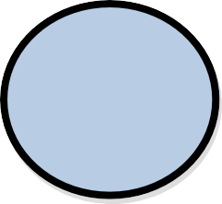Circle, which represents a process that transforms incoming data into outgoing flow.

Open Rectangle, which shows a data store.

**Fig 16: Symbol used In DFD**

## Data Flow Diagram



**7.3.2.1 Context**



ADMIN

1. View
2. edit

0.0

4. employee details

**Human resource** Employee

**management**

5. Position

Dashboard

**Fig 17: Context Diagram**



3. Attendance

#### Level 1 DFD

##### *Admin Module*



Accesses



Username &

ADMIN

Password

Access

Granted



Admin Dashboard



Employee

Schedule

Deduction

Position

Attendance

**Fig 18: Level 1 DFD for Admin Module**

##### *User Module*

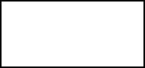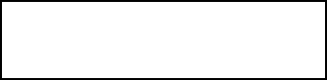

USER

Registered User

Guest User

Register

View Status

Search

Take Refund/Receipt

View Profile

Login

**Fig 19: Level 1 DFD for User Module**

#### Level 2 DFD

##### *Employee Detail Maintenance Module*

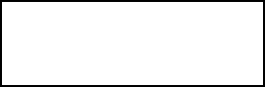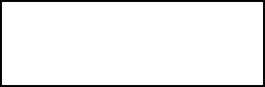

Administrator

Retrieve

Add

Delete

Update

Employee Details

**Fig 20: Level 2 DFD for Employee Detail Maintenance Module**

##### *Salary Management Module*

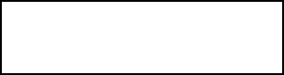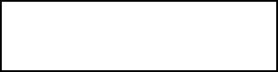

Employee

Pay fees

Administrator

Payments

Issue Receipt

Calculate Fees

Check Dues

Check Usage

Refund Amount

Refund Fees

**Fig 21: Level 2 DFD for Salary Management Module**

## Entity Relationship Diagram



Username

Password

**ADMIN**

**LOGIN**

View, edit

ID

View,edit

Name

Address

Employee id **Organization**

Employee name

Phone

dob

**EMPLOYEE**

Allotted

Phone

Teammate

Deadline

Email id

Salary

Qualification

Designation

**Fig 22: ER Diagram**

## Gantt Chart

A Gantt chart is a type of bar chart that illustrates a project schedule. Gantt charts illustrate the start and finish dates of the terminal elements and summary elements of a project. Terminal elements and summary elements comprise the work breakdown structure of the project. Some Gantt charts also show the dependency (i.e. precedence network) relationships between activities. Gantt charts can be used to show current schedule status using percent-complete shadings and a vertical "TODAY" line as shown here.

Although now regarded as a common charting technique, Gantt charts were considered revolutionary when they were introduced

#### Today

**Fig 23: Gantt chart**

|  |  |  |  |  |  |  |  |  |  |  |  |  |  |  |
| --- | --- | --- | --- | --- | --- | --- | --- | --- | --- | --- | --- | --- | --- | --- |
| **Sr.**  **No.** | **Weeks** | **1** | **2** | **3** | **4** | **5** | **6** | **7** | **8** | **9** | **10** | **11** | **12** | **Status** |
|  |  |  |  |  |  |  |  |  |  |  |  |  |  |  |
| 1. | Feasibility Study |  | |  |  |  |  |  |  |  |  |  |  | **Complete** |
|  |  |  |  |  |  |  |  |  |  |  |  |  |  |  |
| 2. | Requirements Analysis & Specification |  |  |  | | | |  |  |  |  |  |  | **Complete** |
|  |  |  |  |  |  |  |  |  |  |  |  |  |  |  |
| 3. | Design |  |  |  |  | | | | |  | |  |  | **71%Complete** |
|  |  |  |  |  |  |  |  |  |  |  |  |  |  |  |
| 4. | Coding & Unit Testing |  |  |  |  | | | | |  | | |  | **63%Complete** |
|  |  |  |  |  |  |  |  |  |  |  |  |  |  |  |
| 5. | Integration & Unit  Testing |  |  |  |  |  |  |  | |  | | | | **33%Complete** |
|  | | | | | | | | | |  | | | | |

* 1. **Database Design**

The data in the system must be stored and retrieved from database. Designing the database is part of system design. Data elements and data structures to be stored have been identified at analysis stage. They are structured and put together to design the data storage and retrieval system.

A database is a collection of interrelated data stored with minimum redundancy to serve many users quickly and efficiently. The general objective is to make database access easy, quick, inexpensive and flexible for the user. Relationship is established between the data items and unnecessary data items are removed. Normalization is done to get an internal consistency of data and to have minimum redundancy and maximum stability. This ensures minimizing data storage required, minimizing chances of data inconsistencies and optimizing for updates. The Oracle database has been chosen for developing the relevant databases.

**Table 3: Admin Login**

|  |  |  |
| --- | --- | --- |
| **Field Name** | **Data Type** | **Description** |
| Id | INT (11) | Id of the Admin |
| User Name | VARCHAR (30) | User Name |
| First name | VARCHAR (50) | First name of the admin |
| Last name | VARCHAR (50) | Last name of the admin |
| Password | VARCHAR (50) | Password to use |
| Photo | VARCHAR (200) | Photo |
| Created_on | DATE | Date of Admin Create |

**Table 4: Attendance**

|  |  |  |
| --- | --- | --- |
| **Field Name** | **Data Type** | **Description** |
| Id | INT (11) | Id of the Admin |
| Employee Id | INT (11) | Id of the Employee |
| Date | DATE | Date of the month |
| Time_in | TIME | Entry Time |
| Time_out | TIME | Exit Time |
| Status | INT (1) | Status of working |
| Num_hr | DOUBLE | Number of hour |

**Table 5: Cash Advance**

|  |  |  |
| --- | --- | --- |
| **Field Name** | **Data Type** | **Description** |
| Id | INT (11) | Id of the admin |
| Date advance | DATE | Date of the month |
| Employee_id | VARCHAR (15) | Id of the Employee |
| Amount | DOUBLE | Cash |

**Table 6: Deductions**

|  |  |  |
| --- | --- | --- |
| **Field Name** | **Data Type** | **Description** |
| Id | INT (11) | Id of the admin |
| Discription | VARCHAR (100) | Cause |
| Amount | DOUBLE | Cash |

**Table 7: Employees**

|  |  |  |
| --- | --- | --- |
| **Field Name** | **Data Type** | **Description** |
| Id | INT (11) | Id of the Admin |
| Employee_id | VARCHAR (15) | User Name |
| First name | VARCHAR (50) | First name of the admin |
| Last name | VARCHAR (50) | Last name of the admin |
| Address | TEXT | Password to use |
| Birth Date | DATE | Photo |
| Contact_info | VARCHAR (100) | Date of Admin Create |
| Gender | VARCHAR (10) | Gender of the employee |
| Position_id | INT (11) | Position id for employee |
| Schedule_id | INT (11) | Schedule id for employee |
| Photo | VARCHAR (20) | Photo of the employee |
| Created_on | DATE | Date of joining |

**Table 8: Overtime**

|  |  |  |
| --- | --- | --- |
| **Field Name** | **Data Type** | **Description** |
| Id | INT (11) | Id of the admin |
| Date advance | DATE | Date of the month |
| Employee_id | VARCHAR (15) | Id of the Employee |
| Amount | DOUBLE | Cash |

**Table 9: Position**

|  |  |  |
| --- | --- | --- |
| **Field Name** | **Data Type** | **Description** |
| Id | INT (11) | Id of the admin |
| Description | VARCHAR (11) | Position in organization |
| rate | DOUBLE | Salary |

**Table 10: Schedules**

|  |  |  |
| --- | --- | --- |
| **Field Name** | **Data Type** | **Description** |
| Id | INT (11) | Id of the admin |
| Time_in | TIME | Entry Time |
| Time_out | TIME | Exit Time |

# Output Design

Computer output is the most important and direct source of information to the users. Output design is a very important phase since the output needs to be in an efficient manner. Efficient and intelligent output design improves the system relationship with the user and helps in decision making. Allowing the user to view the sample screen is important because the user is the ultimate judge of the quality of output.

Once the output requirement is determined, the system designer can decide what to include in the system and how to structure it so that the required output can be produced. Output must be concerned to the overall performance and the systems working. The output design is the key to the success of any system.

# Chapter 8 Software Tool Used

* 1. **Front End**

This language is used to design our webpage. It is anything that the user can interact directly, that could be an app running in a web browser.

The frontend of the application is noticeable part of the website that the user can interact with it. It is necessary to deliver effective interactivity and helps in displaying of the content and data in a neat and simply to understand.

Different languages come under frontend:-

## HTML5

* + - * The full form of HTML5 is Hyper Text Markup Language Version 5.
      * It is the markup language that is used for creating web pages and web based program.
      * It is a backbone of any web application.
      * It was invented in 1989 by Tim Berners-Lee.
      * It is computer language at the client side which determines how the webpage look in the browser.
      * The extension of HTML is .html.

HTML has the following different versions:

* HTML 2.0
* HTML 3.2
* HTML 4.0

## CSS

The full form of CSS is Cascading Style Sheet. It is a method for

adding styles (font, color, spacing, etc.) to web documents. It is a language for styling and decorating the webpage. It was invented in 1996 by Hakon Wium Lie. It can control the layout of multiples pages at all at once. The extension of CSS file is .CSS. There are three types of CSS are as follows:

* Inline CSS
* Internal CSS
* External CSS
* **Inline CSS:** Inline CSS contains the CSS property in the body section attached with element is known as inline CSS. This kind of style is specified within an HTML tag using style attribute.
* **Internal or Embedded CSS:** This can be used when a single HTML document must be styled uniquely. The CSS rule set should be within the HTML file in the head section i.e. the CSS is embedded within the HTML file.
* **External CSS:** External CSS contains separate CSS file which contains only style property with the help of tag attributes (For example class, id, heading, etc.). CSS property written in a separate file with .css extension and should be linked to the HTML document using link tag. This means that for each element, style can be set only once and that will be applied across web pages.

## Bootstrap

It is use to make a website is responsive so that it can run easily on tablet, mobile, laptop, desktop, etc. Bootstrap is a CSS framework for designing better web pages. It was developed by Mark Otto and Jacob Thornton who were the former twitter employees. It was developed as an internal development tool to improves consistency and efficiency in web pages. This framework is built on HTML, CSS and JS to facility the development of responsive websites.

## JavaScript

It is the language use to make the website interactive for example responses when button are pressed or data entered in forms, dynamic styling and animation, etc. It was invented in 1995 by Brendan Eich. It is the language for programming web pages. It is high level, dynamic, untyped and interpreted runtime language. It in one of the three core technologies of World Wide Web content production. All modern web browser supports it without the need for plug-in. It has an API for working with text, arrays, dates and regular expression.

## Ajax

Ajax stands for Asynchronous JavaScript and XML. It is used for

doing asynchronous communication. With the help of Ajax the web application can able to send and retrieve data from the server in asynchronous manner (In the background) without disturbing the display and behavior of the existing web pages.

## JSON

It stands for JavaScript Object Notation. It is based on a subset of

the JavaScript programming language (Standard ECMA-262 3rd. Edition

– December 1999).

## jQuery

It is a JavaScript library. It stores predefined functions they performs different operations of JavaScript. It was developed by John Resig. Its first release in January 2006 at BarCamp NYC. It makes the work easy like HTML document traversal, manipulation, event handling, animation, and Ajax with the help of simple API that works on every browser. It has change the way of writing the JavaScript.

# Back End

It is used on the server side and therefore called backend. This is used to interact with the Database. Backend development refers to as the development of server side where our primarily focused on how the sites works. The focus was in making updates and changes in additions to monitoring the functionality of the website. It consists of three parts: a server, an application and a database.

## Php

Php is a server-side scripting language designed for Web

development, but also used as a general-purpose programming language. It was originally created by Rasmus Lerdorf in 1994 the PHP reference implementation is now produced by The PHP Group. PHP originally stood for Personal Home Page but it now stands for the recursive acronym PHP: Hypertext Preprocessor.

PHP code may be embedded into HTML code, or it can be used in combination with various web template systems, web content management systems, and web frameworks. PHP code is usually processed by a PHP interpreter implemented as a module in the web server or as a Common Gateway Interface (CGI) executable.

##### *Features of PHP*

The main features of php are; it is open source scripting language so you can free download this and use. PHP is a server site scripting language. It is open source scripting language. It is widely used all over the world. It is faster than other scripting language.

Some important features of php are given below.

* + - * Simple
      * Faster
      * Interpreted
      * Open Source
      * Simplicity
      * Efficiency
      * Platform Independent
      * Security
      * Flexibility
      * Familiarity
      * Error Reporting
      * Loosely Typed Language
      * Real-Time

# CHAPTER 9

**INPUT & OUTPUT CODING OF PROJECT**

* 1. **Index.php**

## Source Code

<? php session_start();

if(isset($_SESSION['admin'])){ header('location:home.php');

}

?>

<?php include 'includes/header.php'; ?>

<body class="hold-transition login-page">

<div class="login-box">

<div class="login-logo">

<b>Admin Login</b>

</div>

<div class="login-box-body">

<p class="login-box-msg">Sign in to start your session</p>

<form action="login.php" method="POST">

<div class="form-group has-feedback">

<input type="text" class="form-control" name="username" placeholder="input Username" required autofocus>

<span class="glyphicon glyphicon-user form-control-feedback"></span>

</div>

<div class="form-group has-feedback">

<input type="password" class="form-control" name="password" placeholder="input Password" required>

<span class="glyphicon glyphicon-lock form-control-feedback"></span>

</div>

<div class="row">

<div class="col-xs-4">

<button type="submit" class="btn btn-primary btn-block btn-flat" name="login"><i class="fa fa-sign-in"></i> Sign In</button>

</div>

</div>

</form>

</div>

<?php if(isset($_SESSION['error'])){ echo "

<div class='callout callout-danger text-center mt20'>

<p>".$_SESSION['error']."</p>

</div> "; unset($_SESSION['error']);

}

?>

</div>

<?php include 'includes/scripts.php' ?>

</body>

</html>

##### *Output*

**Pic. 1- Admin Login Page**

# Home.php

### *Source Code*

<?php include 'includes/session.php'; ?>

<?php

include '../timezone.php';

$today = date('Y-m-d');

$year = date('Y'); if(isset($_GET['year'])){

$year = $_GET['year'];

}

?>

<?php include 'includes/header.php'; ?>

<body class="hold-transition skin-yellow sidebar-mini">

<div class="wrapper">

<?php include 'includes/navbar.php';

<?php include 'includes/menubar.php'; ?>

<!-- Content Wrapper. Contains page content -->

<div class="content-wrapper">

<!-- Content Header (Page header) -->

<section class="content-header">

<h1>

Dashboard

</h1>

<ol class="breadcrumb">

<li><a href="#"><i class="fa fa-dashboard"></i> Home</a></li>

<li class="active">Dashboard</li>

</ol>

</section>

<!-- Main content -->

<section class="content">

<?php if(isset($_SESSION['error'])){ echo "

<div class='alert alert-danger alert-dismissible'>

<button type='button' class='close' data-dismiss='alert' aria- hidden='true'>&times;</button>

<h4><i class='icon fa fa-warning'></i> Error!</h4> ".$_SESSION['error']."

</div> ";

unset($_SESSION['error']);

}

if(isset($_SESSION['success'])){ echo "

<div class='alert alert-success alert-dismissible'>

<button type='button' class='close' data-dismiss='alert' aria- hidden='true'>&times;</button>

<h4><i class='icon fa fa-check'></i> Success!</h4> ".$_SESSION['success']."

</div> "; unset($_SESSION['success']);

}

?>

<!-- Small boxes (Stat box) -->

<div class="row">

<div class="col-lg-3 col-xs-6">

<!-- small box -->

<div class="small-box bg-orange">

<div class="inner">

<?php

$sql = "SELECT * FROM employees";

$query = $conn->query($sql);

echo "<h3>".$query->num_rows."</h3>";

?>

<p>Total Employees</p>

</div>

<div class="icon">

<i class="ion ion-person-stalker"></i>

</div>

<a href="employee.php" class="small-box-footer">More info <i class="fa fa-arrow-circle- right"></i></a>

</div>

</div>

<!-- ./col -->

<div class="col-lg-3 col-xs-6">

<!-- small box -->

<div class="small-box bg-green">

<div class="inner">

<?php

$sql = "SELECT * FROM attendance";

$query = $conn->query($sql);

$total = $query->num_rows;

$sql = "SELECT * FROM attendance WHERE status = 1";

$query = $conn->query($sql);

$early = $query->num_rows;

$percentage = ($early/$total)*100;

echo "<h3>".number_format($percentage, 2)."<sup style='font-size: 20px'>%</sup></h3>";

?>

<p>On Time Percentage</p>

</div>

<div class="icon">

<i class="ion ion-pie-graph"></i>

</div>

<a href="attendance.php" class="small-box-footer">More info <i class="fa fa-arrow-circle- right"></i></a>

</div>

</div>

<!-- ./col -->

<div class="col-lg-3 col-xs-6">

<!-- small box -->

<div class="small-box bg-yellow">

<div class="inner">

<?php

$sql = "SELECT * FROM attendance WHERE date = '$today' AND status = 1";

$query = $conn->query($sql);

echo "<h3>".$query->num_rows."</h3>"

?>

<p>On Time Today</p>

</div>

<div class="icon">

<i class="ion ion-clock"></i>

</div>

<a href="attendance.php" class="small-box-footer">More info <i class="fa fa-arrow-circle- right"></i></a>

</div>

</div>

<!-- ./col -->

<div class="col-lg-3 col-xs-6">

<!-- small box -->

<div class="small-box bg-red">

<div class="inner">

<?php

$sql = "SELECT * FROM attendance WHERE date = '$today' AND status = 0";

$query = $conn->query($sql);

echo "<h3>".$query->num_rows."</h3>"

?>

<p>Late Today</p>

</div>

<div class="icon">

<i class="ion ion-alert-circled"></i>

</div>

<a href="attendance.php" class="small-box-footer">More info <i class="fa fa-arrow-circle- right"></i></a>

</div>

</div>

<!-- ./col -->

</div>

<!-- /.row -->

<div class="row">

<div class="col-xs-12">

<div class="box">

<div class="box-header with-border">

<h3 class="box-title">Monthly Attendance Report</h3>

<div class="box-tools pull-right">

<form class="form-inline">

<div class="form-group">

<label>Select Year: </label>

<select class="form-control input-sm" id="select_year">

<?php

for($i=2015; $i<=2065; $i++){

$selected = ($i==$year)?'selected':''; echo "

<option value='".$i."' ".$selected.">".$i."</option> ";

}

?>

</select>

</div>

</form>

</div>

</div>

<div class="box-body">

<div class="chart">

<br>

<div id="legend" class="text-center"></div>

<canvas id="barChart" style="height:350px"></canvas>

</div>

</div>

</div>

</div>

</div>

</section>

<!-- right col -->

</div>

<?php include 'includes/footer.php'; ?>

</div>

<!-- ./wrapper -->

<!-- Chart Data -->

<?php

$and = 'AND YEAR(date) = '.$year;

$months = array();

$ontime = array();

$late = array();

for( $m = 1; $m <= 12; $m++ ) {

$sql = "SELECT * FROM attendance WHERE MONTH(date) = '$m' AND status = 1 $and";

$oquery = $conn->query($sql); array_push($ontime, $oquery-

>num_rows);

$sql = "SELECT * FROM attendance WHERE MONTH(date) = '$m' AND status = 0 $and";

$lquery = $conn->query($sql); array_push($late, $lquery-

>num_rows);

$num = str_pad( $m, 2, 0, STR_PAD_LEFT );

$month = date('M', mktime(0, 0, 0, $m, 1)); array_push($months,

$month);

}

$months = json_encode($months);

$late = json_encode($late);

$ontime = json_encode($ontime);

?>

<!-- End Chart Data -->

<?php include 'includes/scripts.php'; ?>

<script>

$(function(){

var barChartCanvas = $('#barChart').get(0).getContext('2d') var barChart = new Chart(barChartCanvas)

var barChartData = {

labels : <?php echo $months; ?>, datasets: [

{

label : 'Late',

fillColor : 'rgba(210, 214, 222, 1)',

strokeColor : 'rgba(210, 214, 222, 1)',

pointColor : 'rgba(210, 214, 222, 1)', pointStrokeColor : '#c1c7d1', pointHighlightFill : '#fff', pointHighlightStroke: 'rgba(220,220,220,1)', data : <?php echo $late; ?>

},

{

label : 'Ontime',

fillColor : 'rgba(60,141,188,0.9)', strokeColor

: 'rgba(60,141,188,0.8)', pointColor : '#3b8bba', pointStrokeColor : 'rgba(60,141,188,1)', pointHighlightFill : '#fff', pointHighlightStroke: 'rgba(60,141,188,1)', data : <?php echo $ontime; ?>

}

]

}

barChartData.datasets[1].fillColor = '#00a65a' barChartData.datasets[1].strokeColor = '#00a65a' barChartData.datasets[1].pointColor = '#00a65a' var barChartOptions

= {

//Boolean - Whether the scale should start at zero, or an order of magnitude down from the lowest value

scaleBeginAtZero : true,

//Boolean - Whether grid lines are shown across the chart scaleShowGridLines: true,

//String - Colour of the grid lines scaleGridLineColor : 'rgba(0,0,0,.05)',

//Number - Width of the grid lines scaleGridLineWidth : 1,

//Boolean - Whether to show horizontal lines (except X axis) scaleShowHorizontalLines: true,

//Boolean - Whether to show vertical lines (except Y axis) scaleShowVerticalLines : true,

//Boolean - If there is a stroke on each bar barShowStroke : true,

//Number - Pixel width of the bar stroke barStrokeWidth : 2,

//Number - Spacing between each of the X value sets barValueSpacing : 5,

//Number - Spacing between data sets within X values barDatasetSpacing : 1,

//String - A legend template

legendTemplate : '<ul class="<%=name.toLowerCase()%>- legend"><% for (var i=0; i<datasets.length;

i++){%><li><span style="background-

color:<%=datasets[i].fillColor%>"></span><%if(datasets[i].label){%

><%=datasets[i].label

%><%}%></li><%}%></ul>',

//Boolean - whether to make the chart responsive responsive : true, maintainAspectRatio : true

}

barChartOptions.datasetFill = false

var myChart = barChart.Bar(barChartData, barChartOptions) document.getElementById('legend').innerHTML = myChart.generateLegend();

});

</script>

<script>

$(function(){

$('#select_year').change(function(){ window.location.href = 'home.php?year='+$(this).val();

});

});

</script>

</body>

</html>

### *Output*

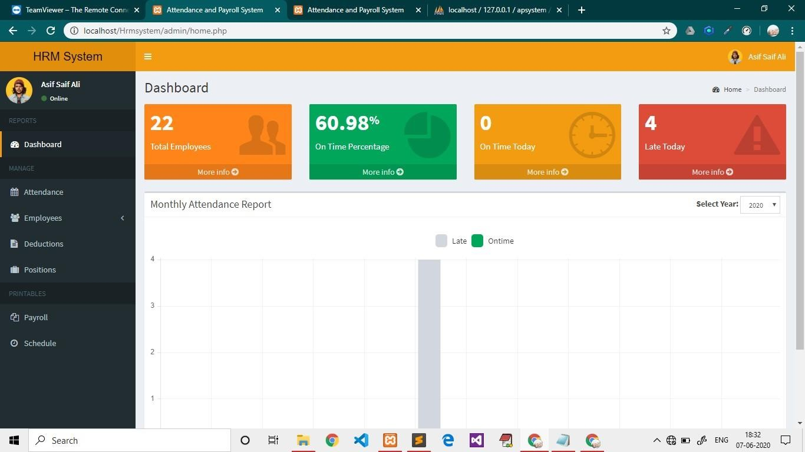

**Pic. 2- Home Page**

# Attendance

### *Source code*

<?php include 'includes/session.php'; ?>

<?php include 'includes/header.php'; ?>

<body class="hold-transition skin-blue sidebar-mini">

<div class="wrapper">

<?php include 'includes/navbar.php'; ?>

<?php include 'includes/menubar.php'; ?>

<!-- Content Wrapper. Contains page content -->

<div class="content-wrapper">

<!-- Content Header (Page header) -->

<section class="content-header">

<h1>

Attendance

</h1>

<ol class="breadcrumb">

<li><a href="#"><i class="fa fa-dashboard"></i> Home</a></li>

<li class="active">Attendance</li>

</ol>

</section>

<!-- Main content -->

<section class="content">

<?php if(isset($_SESSION['error'])){ echo "

<div class='alert alert-danger alert-dismissible'>

<button type='button' class='close' data-dismiss='alert' aria-hidden='true'>&times;</button>

<h4><i class='icon fa fa-warning'></i> Error!</h4> ".$_SESSION['error']."

</div> "; unset($_SESSION['error']);

}

if(isset($_SESSION['success'])){ echo "

<div class='alert alert-success alert-dismissible'>

<button type='button' class='close' data-dismiss='alert' aria-hidden='true'>&times;</button>

<h4><i class='icon fa fa-check'></i> Success!</h4> ".$_SESSION['success']."

</div> ";

unset($_SESSION['success']);

}

?>

<div class="row">

<div class="col-xs-12">

<div class="box">

<div class="box-header with-border">

<a href="#addnew" data-toggle="modal" class="btn btn-primary btn-sm btn-flat"><i class="fa fa-plus"></i> New</a>

</div>

<div class="box-body">

<table id="example1" class="table table-bordered">

<thead>

<th class="hidden"></th>

<th>Date</th>

<th>Employee ID</th>

<th>Name</th>

<th>Time In</th>

<th>Time Out</th>

<th>Tools</th>

</thead>

<tbody>

<?php

$sql = "SELECT *, employees.employee_id AS empid, attendance.id AS attid FROM attendance LEFT JOIN employees ON employees.id=attendance.employee_id ORDER BY attendance.date DESC, attendance.time_in DESC";

$query = $conn->query($sql); while($row = $query->fetch_assoc()){

$status = ($row['status'])?'<span class="label label-warning pull- right">ontime</span>':'<span class="label label-danger pull-right">late</span>';

echo "

<tr>

<td class='hidden'></td>

<td>".date('M d, Y', strtotime($row['date']))."</td>

<td>".$row['empid']."</td>

<td>".$row['firstname'].' '.$row['lastname']."</td>

<td>".date('h:i A', strtotime($row['time_in'])).$status."</td>

<td>".date('h:i A', strtotime($row['time_out']))."</td>

<td>

<button class='btn btn-success btn-sm btn-flat edit' data-id='".$row['attid']."'><i class='fa fa- edit'></i> Edit</button>

<button class='btn btn-danger btn-sm btn-flat delete' data-id='".$row['attid']."'><i class='fa fa- trash'></i> Delete</button>

</td>

</tr> ";

}

?>

</tbody>

</table>

</div>

</div>

</div>

</div>

</section>

</div>

<?php include 'includes/footer.php'; ?>

<?php include 'includes/attendance_modal.php'; ?>

</div>

<?php include 'includes/scripts.php'; ?>

<script>

$(function(){

$('.edit').click(function(e){ e.preventDefault();

$('#edit').modal('show');

var id = $(this).data('id'); getRow(id);

});

$('.delete').click(function(e){ e.preventDefault();

$('#delete').modal('show');

var id = $(this).data('id'); getRow(id);

});

});

function getRow(id){

$.ajax({

type: 'POST',

url: 'attendance_row.php', data: {id:id}, dataType: 'json',

success: function(response){

$('#datepicker_edit').val(response.date);

$('#attendance_date').html(response.date);

$('#edit_time_in').val(response.time_in);

$('#edit_time_out').val(response.time_out);

$('#attid').val(response.attid);

$('#employee_name').html(response.firstname+' '+response.lastname);

$('#del_attid').val(response.attid);

$('#del_employee_name').html(response.firstname+' '+response.lastname);

}

});

}

</script>

</body>

</html>

### *Output*

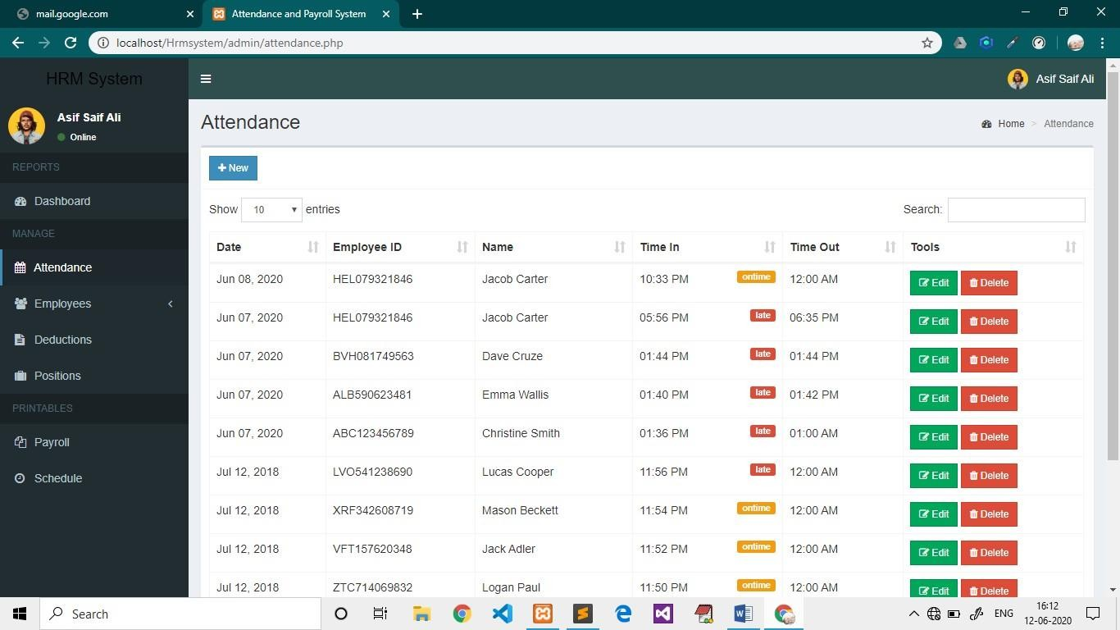

**Pic. 3- Attendance Page**

# Employee.php

### *Source code*

<?php include 'includes/session.php'; ?>

<?php include 'includes/header.php'; ?>

<body class="hold-transition skin-blue sidebar-mini">

<div class="wrapper">

<?php include 'includes/navbar.php'; ?>

<?php include 'includes/menubar.php'; ?>

<!-- Content Wrapper. Contains page content -->

<div class="content-wrapper">

<!-- Content Header (Page header) -->

<section class="content-header">

<h1>

Employee List

</h1>

<ol class="breadcrumb">

<li><a href="#"><i class="fa fa-dashboard"></i> Home</a></li>

<li>Employees</li>

<li class="active">Employee List</li>

</ol>

</section>

<!-- Main content -->

<section class="content">

<?php if(isset($_SESSION['erro r'])){ echo "

<div class='alert alert-danger alert-dismissible'>

<button type='button' class='close' data-dismiss='alert' aria- hidden='true'>&times;</button>

<h4><i class='icon fa fa-warning'></i> Error!</h4>

".$_SESSION['error']."

</div> ";

unset($_SESSION['error']);

}

if(isset($_SESSION['success'])){ echo "

<div class='alert alert-success alert-dismissible'>

<button type='button' class='close' data-dismiss='alert' aria- hidden='true'>&times;</button>

<h4><i class='icon fa fa-check'></i> Success!</h4> ".$_SESSION['success']."

</div> "; unset($_SESSION['success']);

}

?>

<div class="row">

<div class="col-xs-12">

<div class="box">

<div class="box-header with-border">

<a href="#addnew" data-toggle="modal" class="btn btn-primary btn-sm btn-flat"><i class="fa fa-plus"></i> New</a>

</div>

<div class="box-body">

<table id="example1" class="table table-bordered">

<thead>

<th>Employee ID</th>

<th>Photo</th>

<th>Name</th>

<th>Position</th>

<th>Schedule</th>

<th>Member Since</th>

<th>Tools</th>

</thead>

<tbody>

<?php

$sql = "SELECT *, employees.id AS empid FROM employees LEFT JOIN position ON position.id=employees.position_id LEFT JOIN

schedules ON schedules.id=employees.schedule_id";

$query = $conn->query($sql); while($row = $query-

>fetch_assoc()){

?>

<tr>

<td><?php echo $row['employee_id']; ?></td>

<td><img src="<?php echo (!empty($row['photo']))? '../images/'.$row['photo']:'../images/profile.jpg'; ?>" width="30px" height="30px"> <a href="#edit_photo" data-toggle="modal" class="pull-right photo" data-id="<?php echo

$row['empid']; ?>"><span class="fa fa-edit"></span></a></td>

<td><?php echo $row['firstname'].' '.$row['lastname']; ?></td>

<td><?php echo $row['description']; ?></td>

<td><?php echo date('h:i A', strtotime($row['time_in'])).' - '.date('h:i A', strtotime($row['time_out'])); ?></td>

<td><?php echo date('M d, Y', strtotime($row['created_on'])) ?></td>

<td>

<button class="btn btn-success btn-sm edit btn-flat" data-id="<?php echo

$row['empid']; ?>"><i class="fa fa-edit"></i> Edit</button>

<button class="btn btn-danger btn-sm delete btn-flat" data-id="<?php echo

$row['empid']; ?>"><i class="fa fa-trash"></i> Delete</button>

</td>

</tr>

<?php

}

?>

</tbody>

</table>

</div>

</div>

</div>

</div>

</section>

</div>

<?php include 'includes/footer.php'; ?>

<?php include 'includes/employee_modal.php'; ?>

</div>

<?php include 'includes/scripts.php'; ?>

<script>

$(function(){

$('.edit').click(functi on(e){ e.preventDefault();

$('#edit').modal('show'); var id =

$(this).data('id');

getRow(id);

});

$('.delete').click(functi on(e){ e.preventDefault();

$('#delete').modal('show'); var id =

$(this).data('id');

getRow(id);

});

$('.photo').click(function(e){

e.preventDefault(); var id =

$(this).data('id');

getRow(id);

});

});

function getRow(id){

$.ajax({

type: 'POST', url:

'employee_row.php'

, data: {id:id},

dataType: 'json',

success: function(response){

$('.empid').val(response.empid);

$('.employee_id').html(response.employee_id);

$('.del_employee_name').html(response.firstname+' '+response.lastname);

$('#employee_name').html(response.firstname+' '+response.lastname);

$('#edit_firstname').val(response.firstname);

$('#edit_lastname').val(response.lastname);

$('#edit_address').val(response.address);

$('#datepicker_edit').val(response.birthdate);

$('#edit_contact').val(response.contact_info);

$('#gender_val').val(response.gender).html(response.gender);

$('#position_val').val(response.position_id).html(response.description);

$('#schedule_val').val(response.schedule_id).html(response.time_in+' - '+response.time_out);

}

});

}

</script>

</body>

</html>

### *Output*

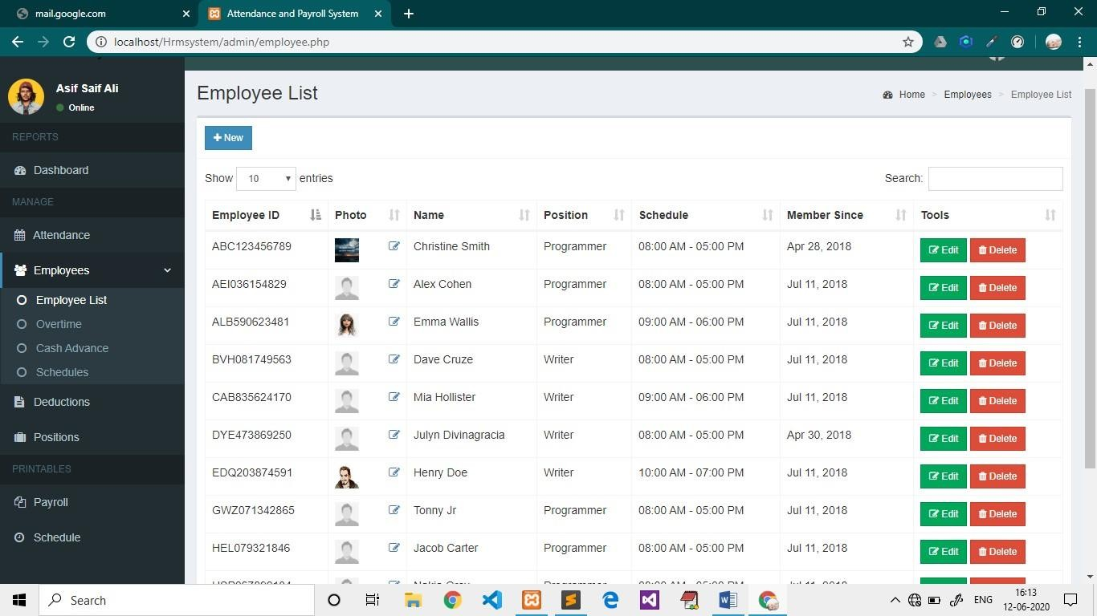

**Pic. 4- Employee Page**

# Overtime.php

### *Source Code*

<!-- Add -->

<div class="modal fade" id="addnew">

<div class="modal-dialog">

<div class="modal-content">

<div class="modal-header">

<button type="button" class="close" data-dismiss="modal" aria-label="Close">

<span aria-hidden="true">&times;</span></button>

<h4 class="modal-title"><b>Add Overtime</b></h4>

</div>

<div class="modal-body">

<form class="form-horizontal" method="POST" action="overtime_add.php">

<div class="form-group">

<label for="employee" class="col-sm-3 control-label">Employee ID</label>

<div class="col-sm-9">

<input type="text" class="form-control" id="employee" name="employee" required>

</div>

</div>

<div class="form-group">

<label for="datepicker_add" class="col-sm-3 control-label">Date</label>

<div class="col-sm-9">

<div class="date">

<input type="text" class="form-control" id="datepicker_add" name="date" required>

</div>

</div>

</div>

<div class="form-group">

<label for="hours" class="col-sm-3 control-label">No. of Hours</label>

<div class="col-sm-9">

<input type="text" class="form-control" id="hours" name="hours">

</div>

</div>

<div class="form-group">

<label for="mins" class="col-sm-3 control-label">No. of Mins</label>

<div class="col-sm-9">

<input type="text" class="form-control" id="mins" name="mins">

</div>

</div>

<div class="form-group">

<label for="rate" class="col-sm-3 control-label">Rate</label>

<div class="col-sm-9">

<input type="text" class="form-control" id="rate" name="rate" required>

</div>

</div>

</div>

<div class="modal-footer">

<button type="button" class="btn btn-default btn-flat pull- left" data- dismiss="modal"><i class="fa fa-close"></i> Close</button>

<button type="submit" class="btn btn-primary btn-flat" name="add"><i class="fa fa- save"></i> Save</button>

</form>

</div>

</div>

</div>

</div>

<!-- Edit -->

<div class="modal fade" id="edit">

<div class="modal-dialog">

<div class="modal-content">

<div class="modal-header">

<button type="button" class="close" data-dismiss="modal" aria-label="Close">

<span aria-hidden="true">&times;</span></button>

<h4 class="modal-title"><b><span class="employee_name"></span></b></h4>

</div>

<div class="modal-body">

<form class="form-horizontal" method="POST" action="overtime_edit.php">

<input type="hidden" class="otid" name="id">

<div class="form-group">

<label for="datepicker_edit" class="col-sm-3 control-label">Date</label>

<div class="col-sm-9">

<div class="date">

<input type="text" class="form-control" id="datepicker_edit" name="date" required>

</div>

</div>

</div>

<div class="form-group">

<label for="hours_edit" class="col-sm-3 control-label">No. of Hours</label>

<div class="col-sm-9">

<input type="text" class="form-control" id="hours_edit" name="hours">

</div>

</div>

<div class="form-group">

<label for="mins_edit" class="col-sm-3 control-label">No. of Mins</label>

<div class="col-sm-9">

<input type="text" class="form-control" id="mins_edit" name="mins">

</div>

</div>

<div class="form-group">

<label for="rate_edit" class="col-sm-3 control-label">Rate</label>

<div class="col-sm-9">

<input type="text" class="form-control" id="rate_edit" name="rate" required>

</div>

</div>

</div>

<div class="modal-footer">

<button type="button" class="btn btn-default btn-flat pull- left" data- dismiss="modal"><i class="fa fa-close"></i> Close</button>

<button type="submit" class="btn btn-success btn-flat" name="edit"><i class="fa fa- check-square-o"></i> Update</button>

</form>

</div>

</div>

</div>

</div>

<!-- Delete -->

<div class="modal fade" id="delete">

<div class="modal-dialog">

<div class="modal-content">

<div class="modal-header">

<button type="button" class="close" data-dismiss="modal" aria-label="Close">

<span aria-hidden="true">&times;</span></button>

<h4 class="modal-title"><b><span id="overtime_date"></span></b></h4>

</div>

<div class="modal-body">

<form class="form-horizontal" method="POST" action="overtime_delete.php">

<input type="hidden" class="otid" name="id">

<div class="text-center">

<p>DELETE OVERTIME</p>

<h2 class="employee_name bold"></h2>

</div>

</div>

<div class="modal-footer">

<button type="button" class="btn btn-default btn-flat pull- left" data- dismiss="modal"><i class="fa fa-close"></i> Close</button>

<button type="submit" class="btn btn-danger btn-flat" name="delete"><i class="fa fa- trash"></i> Delete</button>

</form>

</div>

</div>

</div>

</div>

### *Output*

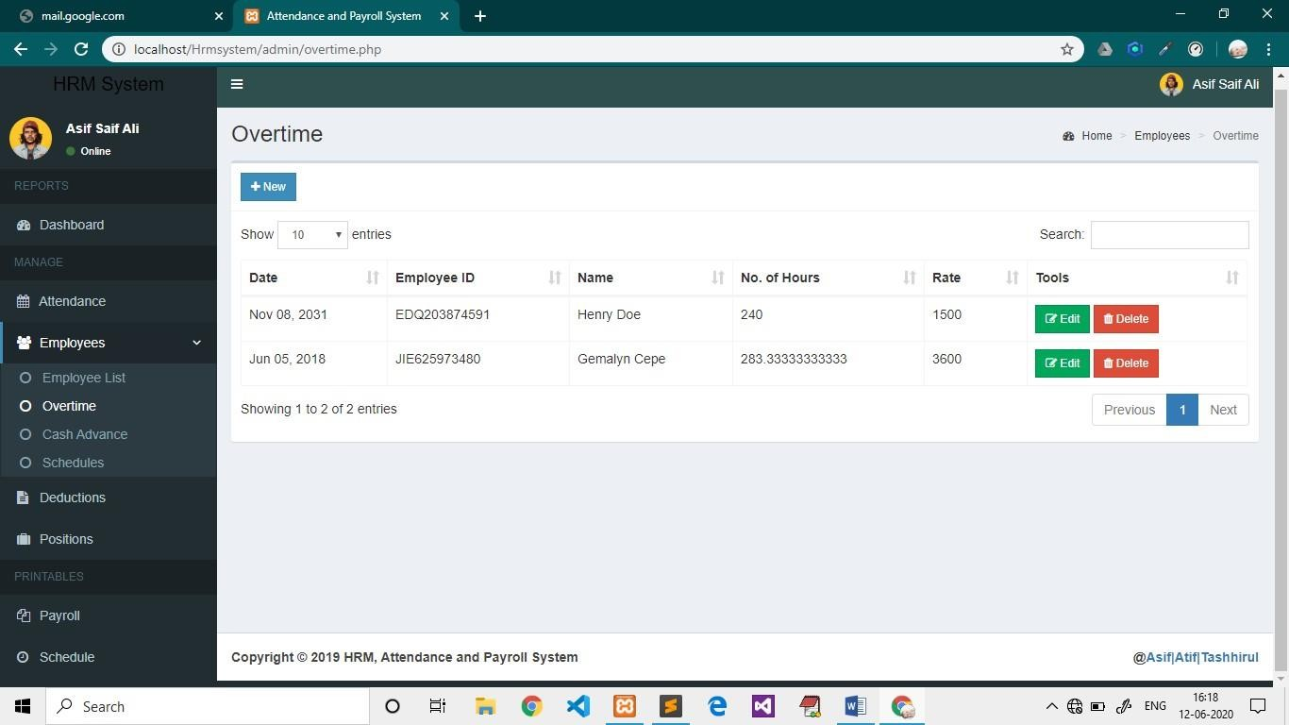

**Pic. 5- Overtime Page**

# Cashadvance.php

### *Source code*

<?php include 'includes/session.php'; ?>

<?php include 'includes/header.php'; ?>

<body class="hold-transition skin-blue sidebar-mini">

<div class="wrapper">

<?php include 'includes/navbar.php'; ?>

<?php include 'includes/menubar.php'; ?>

<!-- Content Wrapper. Contains page content -->

<div class="content-wrapper">

<!-- Content Header (Page header) -->

<section class="content-header">

<h1>

Cash Advance

</h1>

<ol class="breadcrumb">

<li><a href="#"><i class="fa fa-dashboard"></i> Home</a></li>

<li>Employees</li>

<li class="active">Cash Advance</li>

</ol>

</section>

<!-- Main content -->

<section class="content">

<?php if(isset($_SESSION['error'])){ echo "

<div class='alert alert-danger alert-dismissible'>

<button type='button' class='close' data-dismiss='alert' aria- hidden='true'>&times;</button>

<h4><i class='icon fa fa-warning'></i> Error!</h4> ".$_SESSION['error']."

</div> "; unset($_SESSION['error']);

}

if(isset($_SESSION['success'])){ echo "

<div class='alert alert-success alert-dismissible'>

<button type='button' class='close' data-dismiss='alert' aria- hidden='true'>&times;</button>

<h4><i class='icon fa fa-check'></i> Success!</h4> ".$_SESSION['success']."

</div> "; unset($_SESSION['success']);

}

?>

<div class="row">

<div class="col-xs-12">

<div class="box">

<div class="box-header with-border">

<a href="#addnew" data-toggle="modal" class="btn btn-primary btn-sm btn-flat"><i class="fa fa-plus"></i> New</a>

</div>

<div class="box-body">

<table id="example1" class="table table-bordered">

<thead>

<th class="hidden"></th>

<th>Date</th>

<th>Employee ID</th>

<th>Name</th>

<th>Amount</th>

<th>Tools</th>

</thead>

<tbody>

<?php

$sql = "SELECT *, cashadvance.id AS caid, employees.employee_id AS empid FROM cashadvance LEFT JOIN employees ON employees.id=cashadvance.employee_id ORDER BY date_advance DESC";

$query = $conn->query($sql);

while($row = $query->fetch_assoc()){ echo "

<tr>

<td class='hidden'></td>

<td>".date('M d, Y', strtotime($row['date_advance']))."</td>

<td>".$row['empid']."</td>

<td>".$row['firstname'].' '.$row['lastname']."</td>

<td>".number_format($row['amount'], 2)."</td>

<td>

<button class='btn btn-success btn-sm edit btn-flat' data-id='".$row['caid']."'><i class='fa fa- edit'></i> Edit</button>

<button class='btn btn-danger btn-sm delete btn-flat' data-id='".$row['caid']."'><i class='fa fa- trash'></i> Delete</button>

</td>

</tr> ";

}

?>

</tbody>

</table>

</div>

</div>

</div>

</div>

</section>

</div>

<?php include 'includes/footer.php'; ?>

<?php include 'includes/cashadvance_modal.php'; ?>

</div>

<?php include 'includes/scripts.php'; ?>

<script>

$(function(){

$('.edit').click(function(e){ e.preventDefault();

$('#edit').modal('show');

var id = $(this).data('id'); getRow(id);

});

$('.delete').click(function(e){ e.preventDefault();

$('#delete').modal('show');

var id = $(this).data('id'); getRow(id);

});

});

function getRow(id){

$.ajax({

type: 'POST',

url: 'cashadvance_row.php', data: {id:id},

dataType: 'json',

success: function(response){ console.log(response);

$('.date').html(response.date_advance);

$('.employee_name').html(response.firstname+' '+response.lastname);

$('.caid').val(response.caid);

$('#edit_amount').val(response.amount);

}});}

</script>

</body>

</html>

### *output:*

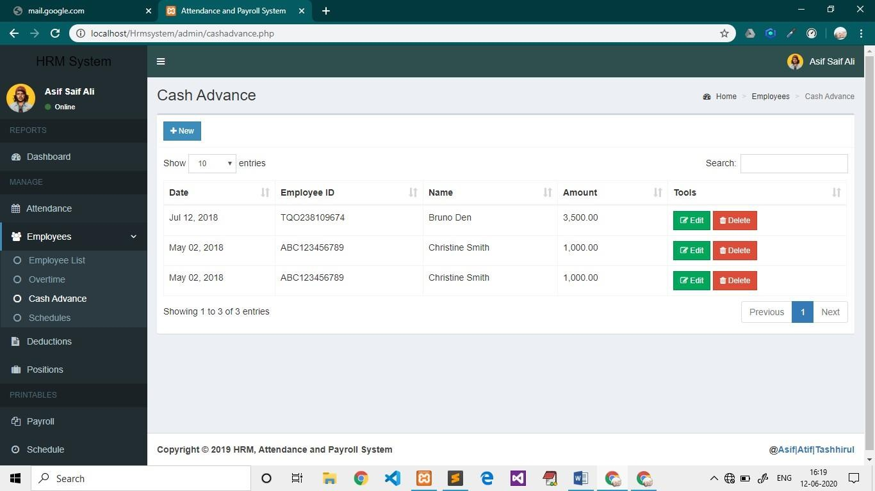

**Pic. 6- Cash Advance Page**

# Schedules.php

### *Source code*

<?php include 'includes/session.php'; ?>

<?php include 'includes/header.php'; ?>

<body class="hold-transition skin-blue sidebar-mini">

<div class="wrapper">

<?php include 'includes/navbar.php'; ?>

<?php include 'includes/menubar.php'; ?>

<!-- Content Wrapper. Contains page content -->

<div class="content-wrapper">

<!-- Content Header (Page header) -->

<section class="content-header">

<h1>

Schedules

</h1>

<ol class="breadcrumb">

<li><a href="#"><i class="fa fa-dashboard"></i> Home</a></li>

<li>Employees</li>

<li class="active">Schedules</li>

</ol>

</section>

<!-- Main content -->

<section class="content">

<?php if(isset($_SESSION['error'])){ echo "

<div class='alert alert-danger alert-dismissible'>

<button type='button' class='close' data-dismiss='alert' aria-hidden='true'>&times;</button>

<h4><i class='icon fa fa-warning'></i> Error!</h4> ".$_SESSION['error']."

</div> "; unset($_SESSION['error']);

}

if(isset($_SESSION['success'])){ echo "

<div class='alert alert-success alert-dismissible'>

<button type='button' class='close' data-dismiss='alert' aria-hidden='true'>&times;</button>

<h4><i class='icon fa fa-check'></i> Success!</h4> ".$_SESSION['success']."

</div> "; unset($_SESSION['success']);

}

?>

<div class="row">

<div class="col-xs-12">

<div class="box">

<div class="box-header with-border">

<a href="#addnew" data-toggle="modal" class="btn btn-primary btn-sm btn-flat"><i class="fa fa-plus"></i> New</a>

</div>

<div class="box-body">

<table id="example1" class="table table-bordered">

<thead>

<th>Time In</th>

<th>Time Out</th>

<th>Tools</th>

</thead>

<tbody>

<?php

$sql = "SELECT * FROM schedules";

$query = $conn->query($sql); while($row = $query->fetch_assoc()){ echo "

<tr>

<td>".date('h:i A', strtotime($row['time_in']))."</td>

<td>".date('h:i A', strtotime($row['time_out']))."</td>

<td>

<button class='btn btn-success btn-sm edit btn-flat' data-id='".$row['id']."'><i class='fa fa- edit'></i> Edit</button>

<button class='btn btn-danger btn-sm delete btn-flat' data-id='".$row['id']."'><i class='fa fa- trash'></i> Delete</button>

</td>

</tr> ";

}

?>

</tbody>

</table>

</div>

</div>

</div>

</div>

</section>

</div>

<?php include 'includes/footer.php'; ?>

<?php include 'includes/schedule_modal.php'; ?>

</div>

<?php include 'includes/scripts.php'; ?>

<script>

$(function(){

$('.edit').click(function(e){ e.preventDefault();

$('#edit').modal('show');

var id = $(this).data('id'); getRow(id);

});

$('.delete').click(function(e){ e.preventDefault();

$('#delete').modal('show');

var id = $(this).data('id'); getRow(id);

});

});

function getRow(id){

$.ajax({

type: 'POST',

url: 'schedule_row.php', data: {id:id}, dataType: 'json',

success: function(response){

$('#timeid').val(response.id);

$('#edit_time_in').val(response.time_in);

$('#edit_time_out').val(response.time_out);

$('#del_timeid').val(response.id);

$('#del_schedule').html(response.time_in+' - '+response.time_out);

}

});

}

</script>

</body>

</html>

### *Output:*

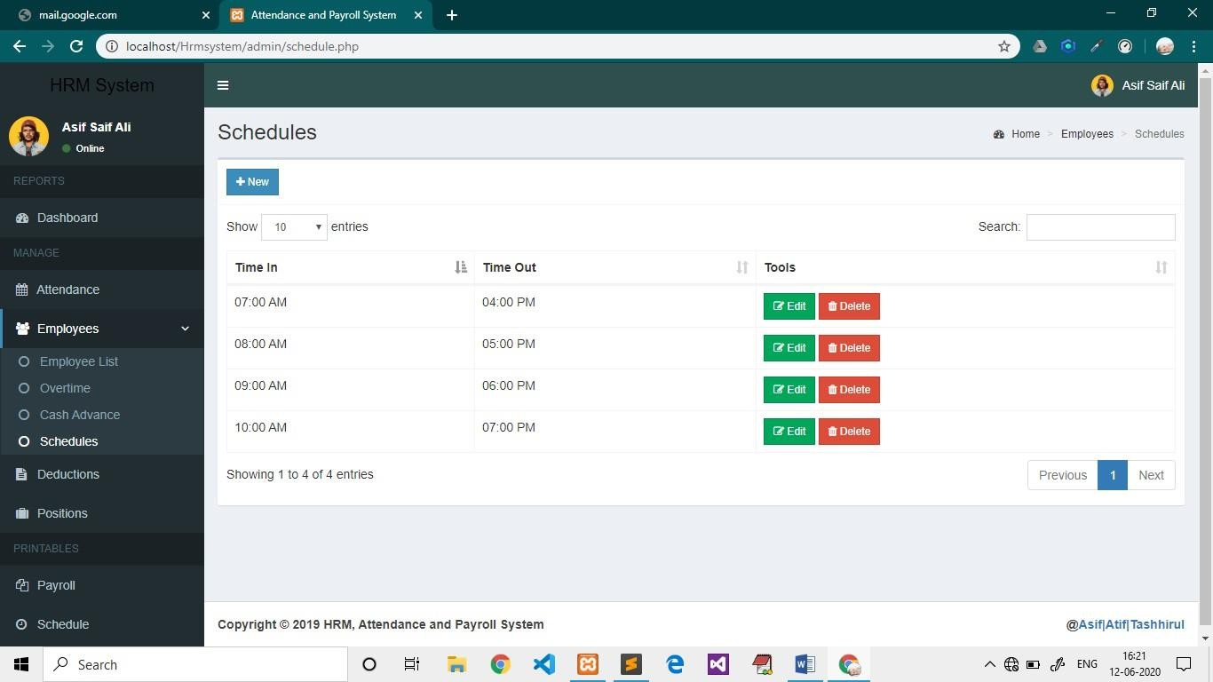

**Pic. 7- Schedules Page**

# Deduction

### *Source code*

<?php include 'includes/session.php'; ?>

<?php include 'includes/header.php'; ?>

<body class="hold-transition skin-blue sidebar-mini">

<div class="wrapper">

<?php include 'includes/navbar.php'; ?>

<?php include 'includes/menubar.php'; ?>

<!-- Content Wrapper. Contains page content -->

<div class="content-wrapper">

<!-- Content Header (Page header) -->

<section class="content-header">

<h1>

Deductions

</h1>

<ol class="breadcrumb">

<li><a href="#"><i class="fa fa-dashboard"></i> Home</a></li>

<li class="active">Deductions</li>

</ol>

</section>

<!-- Main content -->

<section class="content">

<?php if(isset($_SESSION['error'])){ echo "

<div class='alert alert-danger alert-dismissible'>

<button type='button' class='close' data-dismiss='alert' aria-hidden='true'>&times;</button>

<h4><i class='icon fa fa-warning'></i> Error!</h4> ".$_SESSION['error']."

</div> "; unset($_SESSION['error']);

}

if(isset($_SESSION['success'])){ echo "

<div class='alert alert-success alert-dismissible'>

<button type='button' class='close' data-dismiss='alert' aria-hidden='true'>&times;</button>

<h4><i class='icon fa fa-check'></i> Success!</h4> ".$_SESSION['success']."

</div> "; unset($_SESSION['success']);

}

?>

<div class="row">

<div class="col-xs-12">

<div class="box">

<div class="box-header with-border">

<a href="#addnew" data-toggle="modal" class="btn btn-primary btn-sm btn-flat"><i class="fa fa-plus"></i> New</a>

</div>

<div class="box-body">

<table id="example1" class="table table-bordered">

<thead>

<th>Description</th>

<th>Amount</th>

<th>Tools</th>

</thead>

<tbody>

<?php

$sql = "SELECT * FROM deductions";

$query = $conn->query($sql); while($row = $query->fetch_assoc()){ echo "

<tr>

<td>".$row['description']."</td>

<td>".number_format($row['amount'], 2)."</td>

<td>

<button class='btn btn-success btn-sm edit btn-flat' data-id='".$row['id']."'><i class='fa fa- edit'></i> Edit</button>

<button class='btn btn-danger btn-sm delete btn-flat' data-id='".$row['id']."'><i class='fa fa- trash'></i> Delete</button>

</td>

</tr> ";

}

?>

</tbody>

</table>

</div>

</div>

</div>

</div>

</section>

</div>

<?php include 'includes/footer.php'; ?>

<?php include 'includes/deduction_modal.php'; ?>

</div>

<?php include 'includes/scripts.php'; ?>

<script>

$(function(){

$('.edit').click(function(e){ e.preventDefault();

$('#edit').modal('show');

var id = $(this).data('id'); getRow(id);

});

$('.delete').click(function(e){ e.preventDefault();

$('#delete').modal('show');

var id = $(this).data('id'); getRow(id);

});

});

function getRow(id){

$.ajax({

type: 'POST',

url: 'deduction_row.php', data: {id:id}, dataType: 'json',

success: function(response){

$('.decid').val(response.id);

$('#edit_description').val(response.description);

$('#edit_amount').val(response.amount);

$('#del_deduction').html(response.description);

}

});

}

</script>

</body>

</html>

### *Output*

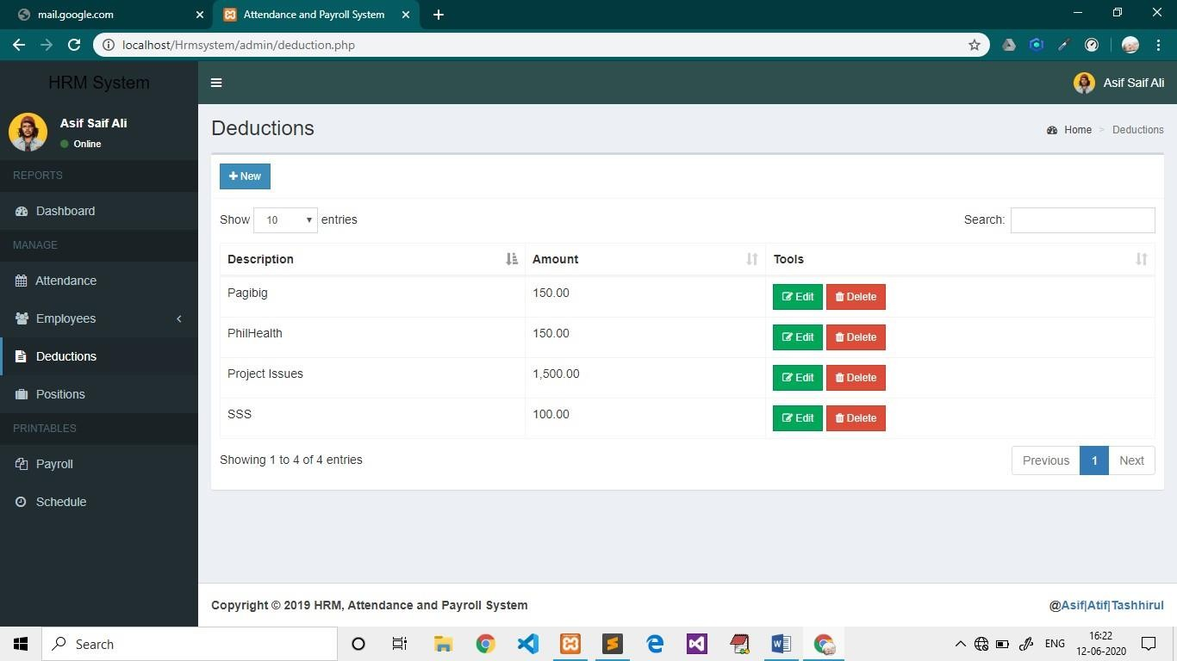

**Pic. 2- Deductio Page**

# Positions

### *Source code*

<?php include 'includes/session.php'; ?>

<?php include 'includes/header.php'; ?>

<body class="hold-transition skin-blue sidebar-mini">

<div class="wrapper">

<?php include 'includes/navbar.php'; ?>

<?php include 'includes/menubar.php'; ?>

<!-- Content Wrapper. Contains page content -->

<div class="content-wrapper">

<!-- Content Header (Page header) -->

<section class="content-header">

<h1>

Positions

</h1>

<ol class="breadcrumb">

<li><a href="#"><i class="fa fa-dashboard"></i> Home</a></li>

<li class="active">Positions</li>

</ol>

</section>

<!-- Main content -->

<section class="content">

<?php if(isset($_SESSION['error'])){ echo "

<div class='alert alert-danger alert-dismissible'>

<button type='button' class='close' data-dismiss='alert' aria-hidden='true'>&times;</button>

<h4><i class='icon fa fa-warning'></i> Error!</h4> ".$_SESSION['error']."

</div> "; unset($_SESSION['error']);

}

if(isset($_SESSION['success'])){ echo "

<div class='alert alert-success alert-dismissible'>

<button type='button' class='close' data-dismiss='alert' aria-hidden='true'>&times;</button>

<h4><i class='icon fa fa-check'></i> Success!</h4> ".$_SESSION['success']."

</div> "; unset($_SESSION['success']);

}

?>

<div class="row">

<div class="col-xs-12">

<div class="box">

<div class="box-header with-border">

<a href="#addnew" data-toggle="modal" class="btn btn-primary btn-sm btn-flat"><i class="fa fa-plus"></i> New</a>

</div>

<div class="box-body">

<table id="example1" class="table table-bordered">

<thead>

<th>Position Title</th>

<th>Rate per Hour</th>

<th>Tools</th>

</thead>

<tbody>

<?php

$sql = "SELECT * FROM position";

$query = $conn->query($sql); while($row = $query->fetch_assoc()){ echo "

<tr>

<td>".$row['description']."</td>

<td>".number_format($row['rate'], 2)."</td>

<td>

<button class='btn btn-success btn-sm edit btn-flat' data-id='".$row['id']."'><i class='fa fa- edit'></i> Edit</button>

<button class='btn btn-danger btn-sm delete btn-flat' data-id='".$row['id']."'><i class='fa fa- trash'></i> Delete</button>

</td>

</tr> ";

}

?>

</tbody>

</table>

</div>

</div>

</div>

</div>

</section>

</div>

<?php include 'includes/footer.php'; ?>

<?php include 'includes/position_modal.php'; ?>

</div>

<?php include 'includes/scripts.php'; ?>

<script>

$(function(){

$('.edit').click(function(e){ e.preventDefault();

$('#edit').modal('show');

var id = $(this).data('id'); getRow(id);

});

$('.delete').click(function(e){ e.preventDefault();

$('#delete').modal('show');

var id = $(this).data('id'); getRow(id);

});

});

function getRow(id){

$.ajax({

type: 'POST',

url: 'position_row.php', data: {id:id}, dataType: 'json', success: function(response){

$('#posid').val(response.id);

$('#edit_title').val(response.description);

$('#edit_rate').val(response.rate);

$('#del_posid').val(response.id);

$('#del_position').html(response.description);

}

});

}

</script>

</body>

</html>

### *Output*



**Pic. 2- Position Page**

# Sql Query

-- phpMyAdmin SQL Dump

-- version 4.8.3

-- https://[www.phpmyadmin.net/](http://www.phpmyadmin.net/)

--

-- Host: localhost:3306

-- Generation Time: Jun 07, 2020 at 01:15 PM

-- Server version: 5.7.24

-- PHP Version: 7.3.7

SET SQL_MODE = "NO_AUTO_VALUE_ON_ZERO"; SET AUTOCOMMIT = 0;

START TRANSACTION;

SET time_zone = "+00:00";

/*!40101 SET @OLD_CHARACTER_SET_CLIENT=@@CHARACTER_SET_CLIENT */;

/*!40101 SET @OLD_CHARACTER_SET_RESULTS=@@CHARACTER_SET_RESULTS */;

/*!40101 SET @OLD_COLLATION_CONNECTION=@@COLLATION_CONNECTION */;

/*!40101 SET NAMES utf8mb4 */;

--

-- Database: `apsystem`

--

-- --------------------------------------------------------

--

-- Table structure for table `admin`

--

CREATE TABLE `admin` (

`id` int(11) NOT NULL,

`username` varchar(30) NOT NULL,

`password` varchar(60) NOT NULL,

`firstname` varchar(50) NOT NULL,

`lastname` varchar(50) NOT NULL,

`photo` varchar(200) NOT NULL,

`created_on` date NOT NULL

) ENGINE=InnoDB DEFAULT CHARSET=latin1;

--

-- Dumping data for table `admin`

--

INSERT INTO `admin` (`id`, `username`, `password`, `firstname`, `lastname`, `photo`,

`created_on`) VALUES

(1, 'admin', '$2y$10$fCOiMky4n5hCJx3cpsG20Od4wHtlkCLKmO6VLobJNRIg9ooHTkgjK', 'Harry', 'Den', 'male6.jpg', '2018-04-30');

-- --------------------------------------------------------

--

-- Table structure for table `attendance`

--

CREATE TABLE `attendance` (

`id` int(11) NOT NULL,

`employee_id` int(11) NOT NULL,

`date` date NOT NULL,

`time_in` time NOT NULL,

`status` int(1) NOT NULL,

`time_out` time DEFAULT '00:00:00',

`num_hr` double DEFAULT NULL

) ENGINE=InnoDB DEFAULT CHARSET=latin1;

--

-- Dumping data for table `attendance`

--

INSERT INTO `attendance` (`id`, `employee_id`, `date`, `time_in`, `status`, `time_out`, `num_hr`) VALUES

(13, 1, '2018-04-27', '08:00:00', 1, '17:00:00', 8),

(14, 1, '2018-04-28', '08:00:00', 1, '17:00:00', 8),

(15, 1, '2018-05-04', '08:00:00', 1, '17:00:00', 8),

(16, 1, '2018-05-02', '08:00:00', 1, '17:00:00', 8),

(17, 1, '2018-05-01', '08:00:00', 1, '17:00:00', 8),

(18, 1, '2018-05-03', '08:00:00', 1, '17:00:00', 8),

(74, 1, '2018-04-30', '08:00:00', 1, '16:44:23', 7.7333333333333),

(75, 3, '2018-04-18', '08:00:00', 1, '17:00:00', 8),

(76, 4, '2018-04-19', '08:00:00', 1, '17:00:00', 8),

(77, 4, '2018-04-27', '08:00:00', 1, '17:00:00', 7),

(78, 4, '2018-04-28', '08:00:00', 1, '17:00:00', 8),

(79, 4, '2018-05-01', '08:30:00', 1, '17:00:00', 8),

(80, 4, '2018-05-03', '08:00:00', 1, '17:00:00', 0),

(81, 4, '2018-05-05', '08:00:00', 1, '17:00:00', 9),

(83, 4, '2018-05-31', '12:00:00', 0, '18:00:00', 5),

(84, 4, '2018-05-18', '08:00:00', 1, '17:00:00', 7),

(85, 4, '2018-05-09', '09:00:00', 1, '18:00:00', 8),

(86, 5, '2018-07-11', '07:41:00', 1, '16:00:00', 7),

(87, 1, '2018-07-11', '06:27:00', 1, '15:00:00', 6),

(88, 6, '2018-07-11', '07:45:00', 1, '14:48:00', 3.8),

(89, 7, '2018-07-11', '07:56:00', 1, '17:00:00', 8),

(90, 8, '2018-07-11', '06:05:12', 1, '16:00:00', 7),

(91, 9, '2018-07-11', '18:12:06', 0, '00:00:00', 0),

(92, 10, '2018-07-11', '18:13:01', 0, '00:00:00', 0),

(93, 11, '2018-07-11', '18:14:30', 0, '00:00:00', 0),

(94, 12, '2018-07-11', '18:16:14', 0, '00:00:00', 0),

(95, 13, '2018-07-11', '18:17:32', 0, '00:00:00', 0),

(96, 14, '2018-07-11', '18:18:33', 0, '00:00:00', 0),

(97, 15, '2018-07-11', '18:19:26', 0, '00:00:00', 0),

(98, 16, '2018-07-11', '18:20:26', 0, '00:00:00', 0),

(99, 17, '2018-07-11', '18:21:41', 0, '00:00:00', 0),

(100, 18, '2018-07-12', '23:46:31', 1, '00:00:00', 0),

(101, 19, '2018-07-12', '23:50:28', 1, '00:00:00', 0),

(102, 20, '2018-07-12', '23:52:48', 1, '00:00:00', 0),

(103, 21, '2018-07-12', '23:54:50', 1, '00:00:00', 0),

(104, 22, '2018-07-12', '23:56:02', 0, '00:00:00', 22.933333333333),

(105, 23, '2018-07-12', '13:57:00', 0, '00:00:00', 12.95),

(106, 1, '2020-06-07', '13:36:19', 0, NULL, NULL),

(107, 13, '2020-06-07', '13:40:08', 0, '13:42:42', 0.033333333333333),

(108, 18, '2020-06-07', '13:44:02', 0, '13:44:11', 0);

-- --------------------------------------------------------

--

-- Table structure for table `cashadvance`

--

CREATE TABLE `cashadvance` (

`id` int(11) NOT NULL,

`date_advance` date NOT NULL,

`employee_id` varchar(15) NOT NULL,

`amount` double NOT NULL

) ENGINE=InnoDB DEFAULT CHARSET=latin1;

--

-- Dumping data for table `cashadvance`

--

INSERT INTO `cashadvance` (`id`, `date_advance`, `employee_id`, `amount`) VALUES (2, '2018-05-02', '1', 1000),

(3, '2018-05-02', '1', 1000),

(4, '2018-07-12', '5', 3500);

-- --------------------------------------------------------

--

-- Table structure for table `deductions`

--

CREATE TABLE `deductions` (

`id` int(11) NOT NULL,

`description` varchar(100) NOT NULL,

`amount` double NOT NULL

) ENGINE=InnoDB DEFAULT CHARSET=latin1;

--

-- Dumping data for table `deductions`

--

INSERT INTO `deductions` (`id`, `description`, `amount`) VALUES (1, 'SSS', 100),

(2, 'Pagibig', 150),

(3, 'PhilHealth', 150),

(4, 'Project Issues', 1500);

-- --------------------------------------------------------

--

-- Table structure for table `employees`

--

CREATE TABLE `employees` (

`id` int(11) NOT NULL,

`employee_id` varchar(15) NOT NULL,

`firstname` varchar(50) NOT NULL,

`lastname` varchar(50) NOT NULL,

`address` text NOT NULL,

`birthdate` date NOT NULL,

`contact_info` varchar(100) NOT NULL,

`gender` varchar(10) NOT NULL,

`position_id` int(11) NOT NULL,

`schedule_id` int(11) NOT NULL,

`photo` varchar(200) NOT NULL,

`created_on` date NOT NULL

) ENGINE=InnoDB DEFAULT CHARSET=latin1;

--

-- Dumping data for table `employees`

--

INSERT INTO `employees` (`id`, `employee_id`, `firstname`, `lastname`, `address`, `birthdate`,

`contact_info`, `gender`, `position_id`, `schedule_id`, `photo`, `created_on`) VALUES

(1, 'ABC123456789', 'Christine', 'Smith', 'Brgy. Mambulac, Silay City', '2018-04-02', '09000035719', 'Female', 1, 2, 'desktop.jpg', '2018-04-28'),

(3, 'DYE473869250', 'Julyn', 'Divinagracia', 'E.B. Magalona', '1992-05-02', '09123456789', 'Female',

2, 2, '', '2018-04-30'),

(4, 'JIE625973480', 'Gemalyn', 'Cepe', 'Carmen, Bohol', '1995-10-02', '09468029840', 'Female', 2, 3,

'', '2018-04-30'),

(5, 'TQO238109674', 'Bruno', 'Den', 'Test', '1995-08-23', '5454578965', 'Male', 1, 2,

'thanossmile.jpg', '2018-07-11'),

(6, 'EDQ203874591', 'Henry', 'Doe', 'New St. Esp', '1991-07-25', '9876543210', 'Male', 2, 4,

'male.png', '2018-07-11'),

(7, 'TWY781946302', 'Johnny', 'Jr', 'Esp', '1995-07-11', '8467067344', 'Male', 1, 2, 'profile.jpg',

'2018-07-11'),

(8, 'GWZ071342865', 'Tonny', 'Jr', 'Esp 12 South Street', '1994-07-19', '9876543210', 'Male', 1, 2,

'profile.jpg', '2018-07-11'),

(9, 'HEL079321846', 'Jacob', 'Carter', 'St12 N1', '1995-07-18', '5454578965', 'Male', 1, 2,

'profile.jpg', '2018-07-11'),

(10, 'OCN273564901', 'Benjamin', 'Cohen', 'TEST', '1991-07-25', '78548852145', 'Male', 2, 3,

'profile.jpg', '2018-07-11'),

(11, 'PGX413705682', 'Ethan', 'Carson', 'DEMO', '1994-07-19', '8467067344', 'Male', 1, 2,

'profile.jpg', '2018-07-11'),

(12, 'YWX536478912', 'Daniel', 'Cooper', 'Test', '1995-07-11', '9876543210', 'Male', 2, 4,

'profile.jpg', '2018-07-11'),

(13, 'ALB590623481', 'Emma', 'Wallis', 'Test', '1994-07-19', '9632145655', 'Female', 1, 3,

'female4.jpg', '2018-07-11'),

(14, 'IOV153842976', 'Sophia', 'Maguire', 'Test', '1995-07-11', '5454578965', 'Female', 2, 2,

'profile.jpg', '2018-07-11'),

(15, 'CAB835624170', 'Mia', 'Hollister', 'Test', '1995-07-18', '9632145655', 'Female', 2, 3,

'profile.jpg', '2018-07-11'),

(16, 'MGZ312906745', 'Emily', 'JK', 'Test', '1996-07-24', '9876543210', 'Female', 2, 3, 'profile.jpg',

'2018-07-11'),

(17, 'HSP067892134', 'Nakia', 'Grey', 'Test', '1995-10-24', '8467067344', 'Female', 1, 2, 'profile.jpg',

'2018-07-11'),

(18, 'BVH081749563', 'Dave', 'Cruze', 'Demo', '1990-01-02', '5454578965', 'Male', 2, 2, 'profile.jpg',

'2018-07-11'),

(19, 'ZTC714069832', 'Logan', 'Paul', 'Esp 16', '1994-12-30', '0202121255', 'Male', 1, 1, 'profile.jpg',

'2018-07-11'),

(20, 'VFT157620348', 'Jack', 'Adler', 'Test', '1991-07-25', '6545698880', 'Male', 1, 4, 'profile.jpg',

'2018-07-11'),

(21, 'XRF342608719', 'Mason', 'Beckett', 'Demo', '1996-07-24', '8467067344', 'Male', 2, 1,

'profile.jpg', '2018-07-11'),

(22, 'LVO541238690', 'Lucas', 'Cooper', 'Demo', '1995-07-18', '9632145655', 'Male', 2, 1,

'profile.jpg', '2018-07-11'),

(23, 'AEI036154829', 'Alex', 'Cohen', 'Demo', '1995-08-23', '9632145655', 'Male', 1, 2, 'profile.jpg',

'2018-07-11');

-- --------------------------------------------------------

--

-- Table structure for table `overtime`

--

CREATE TABLE `overtime` (

`id` int(11) NOT NULL,

`employee_id` varchar(15) NOT NULL,

`hours` double NOT NULL,

`rate` double NOT NULL,

`date_overtime` date NOT NULL

) ENGINE=InnoDB DEFAULT CHARSET=latin1;

--

-- Dumping data for table `overtime`

--

INSERT INTO `overtime` (`id`, `employee_id`, `hours`, `rate`, `date_overtime`) VALUES (4, '6', 240, 1500, '2031-11-08'),

(5, '4', 283.33333333333, 3600, '2018-06-05');

-- --------------------------------------------------------

--

-- Table structure for table `position`

--

CREATE TABLE `position` (

`id` int(11) NOT NULL,

`description` varchar(150) NOT NULL,

`rate` double NOT NULL

) ENGINE=InnoDB DEFAULT CHARSET=latin1;

--

-- Dumping data for table `position`

--

INSERT INTO `position` (`id`, `description`, `rate`) VALUES (1, 'Programmer', 100),

(2, 'Writer', 50),

(3, 'Marketing ', 35),

(4, 'Graphic Designer', 80);

-- --------------------------------------------------------

--

-- Table structure for table `schedules`

--

CREATE TABLE `schedules` (

`id` int(11) NOT NULL,

`time_in` time NOT NULL,

`time_out` time NOT NULL

) ENGINE=InnoDB DEFAULT CHARSET=latin1;

--

-- Dumping data for table `schedules`

--

INSERT INTO `schedules` (`id`, `time_in`, `time_out`) VALUES (1, '07:00:00', '16:00:00'),

(2, '08:00:00', '17:00:00'),

(3, '09:00:00', '18:00:00'),

(4, '10:00:00', '19:00:00');

--

-- Indexes for dumped tables

--

--

-- Indexes for table `admin`

--

ALTER TABLE `admin` ADD PRIMARY KEY (`id`);

--

-- Indexes for table `attendance`

--

ALTER TABLE `attendance` ADD PRIMARY KEY (`id`);

--

-- Indexes for table `cashadvance`

--

ALTER TABLE `cashadvance` ADD PRIMARY KEY (`id`);

--

-- Indexes for table `deductions`

--

ALTER TABLE `deductions` ADD PRIMARY KEY (`id`);

--

-- Indexes for table `employees`

--

ALTER TABLE `employees` ADD PRIMARY KEY (`id`);

--

-- Indexes for table `overtime`

--

ALTER TABLE `overtime` ADD PRIMARY KEY (`id`);

--

-- Indexes for table `position`

--

ALTER TABLE `position` ADD PRIMARY KEY (`id`);

--

-- Indexes for table `schedules`

--

ALTER TABLE `schedules` ADD PRIMARY KEY (`id`);

--

-- AUTO_INCREMENT for dumped tables

--

--

-- AUTO_INCREMENT for table `admin`

--

ALTER TABLE `admin`

MODIFY `id` int(11) NOT NULL AUTO_INCREMENT, AUTO_INCREMENT=2;

--

-- AUTO_INCREMENT for table `attendance`

--

ALTER TABLE `attendance`

MODIFY `id` int(11) NOT NULL AUTO_INCREMENT, AUTO_INCREMENT=109;

--

-- AUTO_INCREMENT for table `cashadvance`

--

ALTER TABLE `cashadvance`

MODIFY `id` int(11) NOT NULL AUTO_INCREMENT, AUTO_INCREMENT=5;

--

-- AUTO_INCREMENT for table `deductions`

--

ALTER TABLE `deductions`

MODIFY `id` int(11) NOT NULL AUTO_INCREMENT, AUTO_INCREMENT=5;

--

-- AUTO_INCREMENT for table `employees`

--

ALTER TABLE `employees`

MODIFY `id` int(11) NOT NULL AUTO_INCREMENT, AUTO_INCREMENT=24;

--

-- AUTO_INCREMENT for table `overtime`

--

ALTER TABLE `overtime`

MODIFY `id` int(11) NOT NULL AUTO_INCREMENT, AUTO_INCREMENT=6;

--

-- AUTO_INCREMENT for table `position`

--

ALTER TABLE `position`

MODIFY `id` int(11) NOT NULL AUTO_INCREMENT, AUTO_INCREMENT=5;

--

-- AUTO_INCREMENT for table `schedules`

--

ALTER TABLE `schedules`

MODIFY `id` int(11) NOT NULL AUTO_INCREMENT, AUTO_INCREMENT=5; COMMIT;

/*!40101 SET CHARACTER_SET_CLIENT=@OLD_CHARACTER_SET_CLIENT */;

/*!40101 SET CHARACTER_SET_RESULTS=@OLD_CHARACTER_SET_RESULTS */;

/*!40101 SET COLLATION_CONNECTION=@OLD_COLLATION_CONNECTION */;

# Database Connectivity

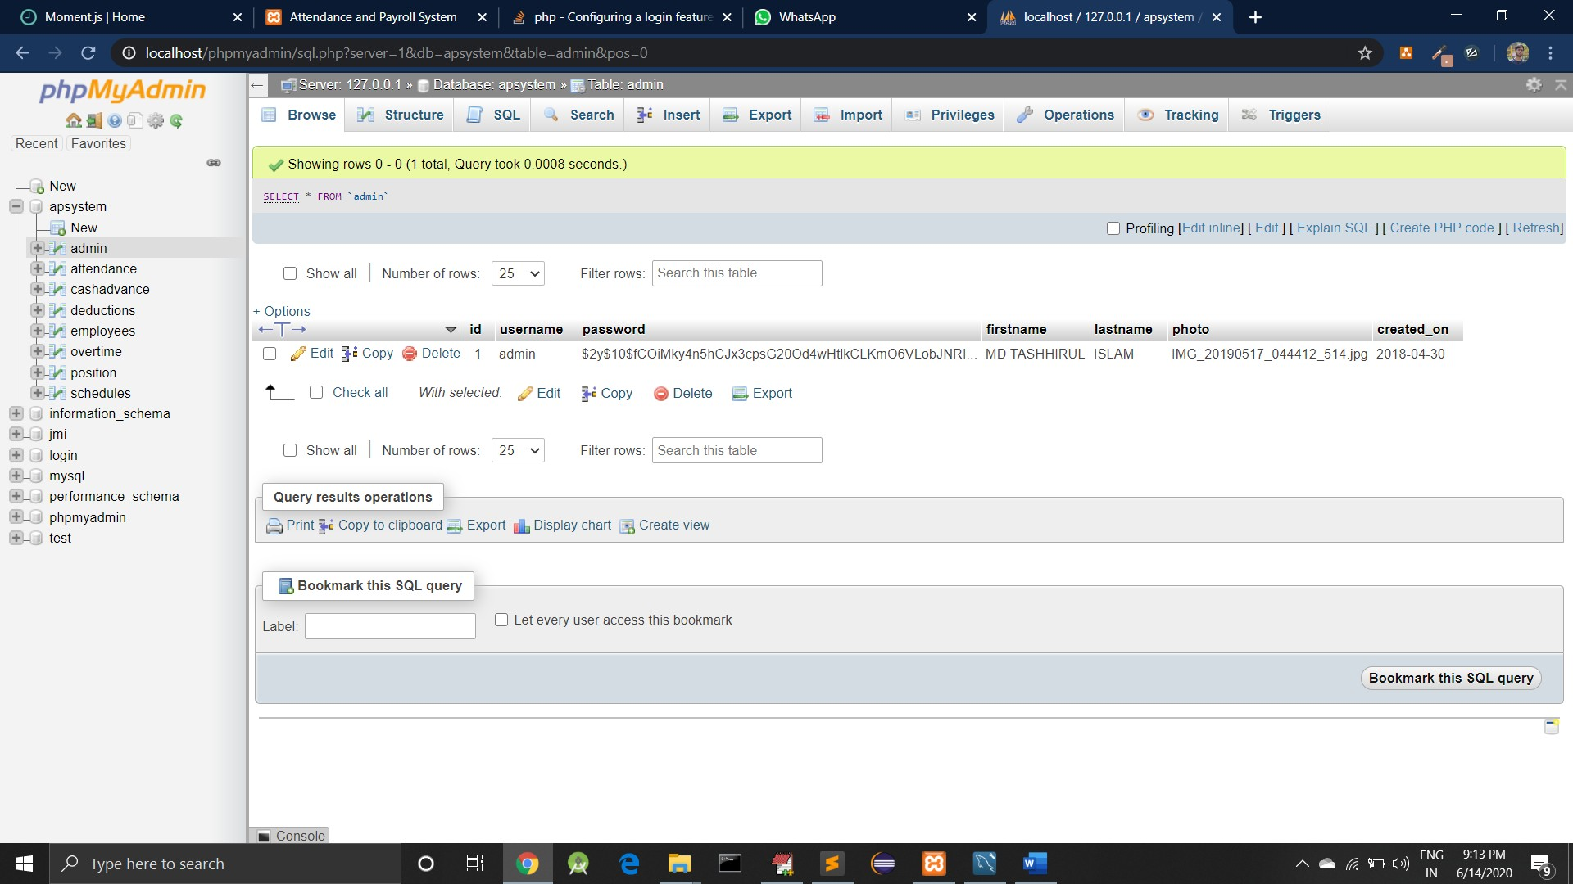

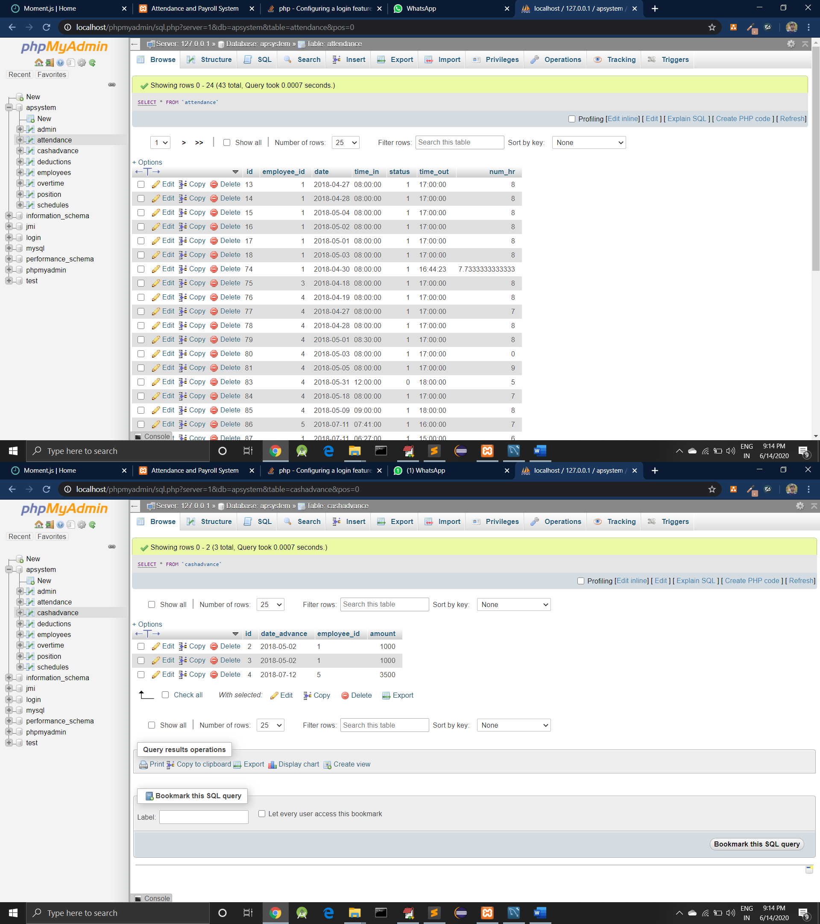

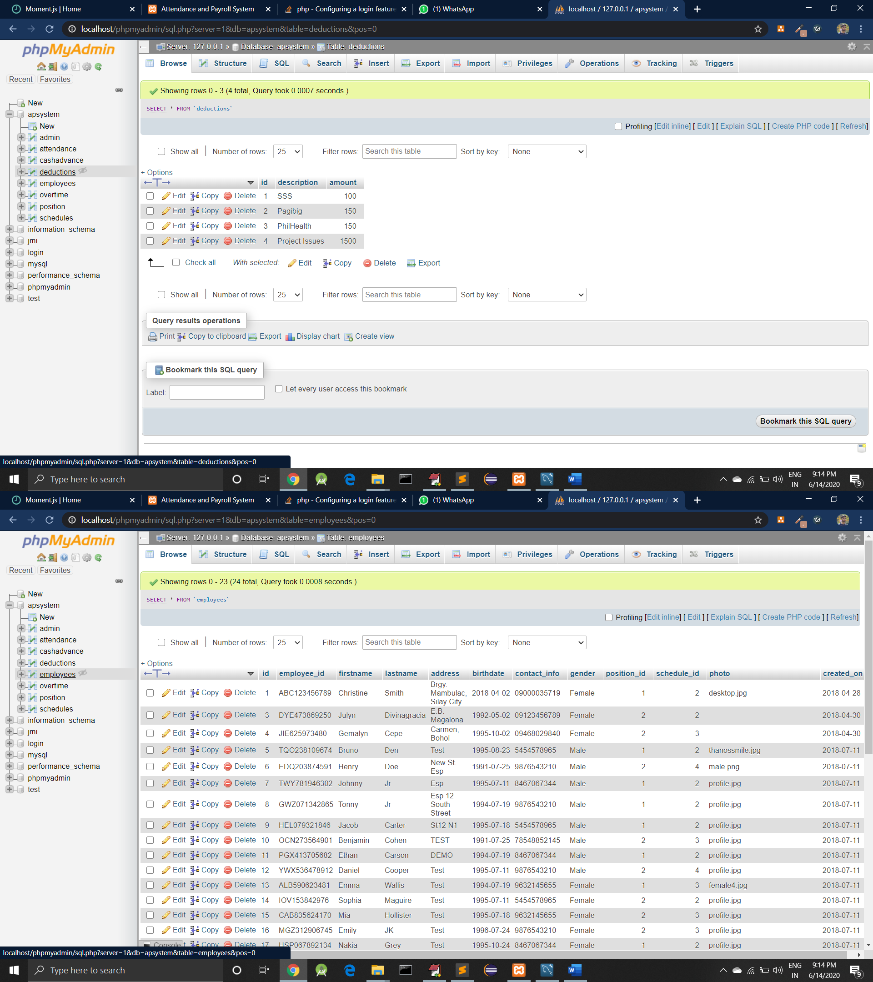

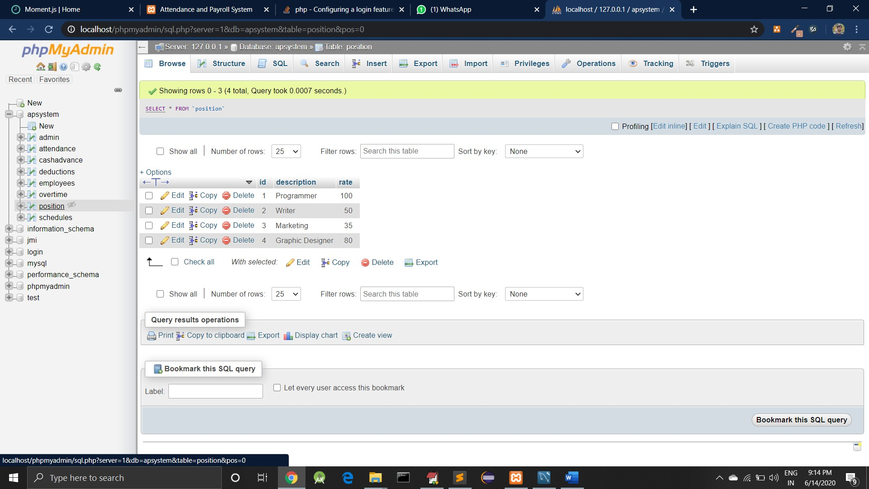

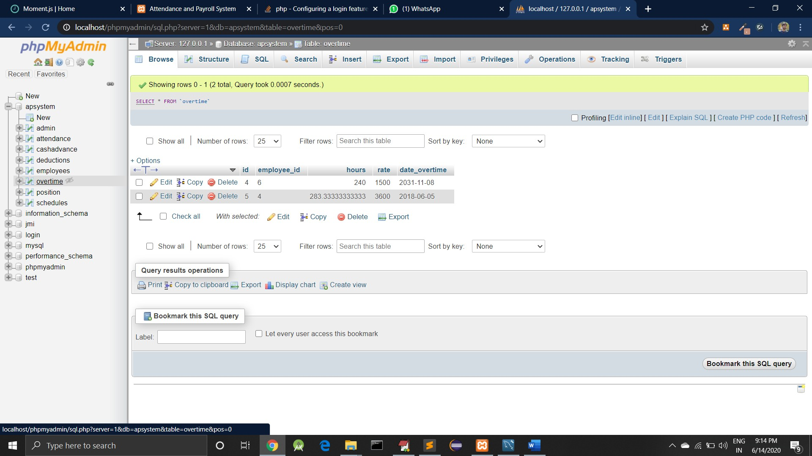

**CHAPTER 10 CONCLUSION**

* 1. **Conclusion**
     + While developing the system a conscious effort has been made to create and develop a software package, making use of available tools, techniques and resources – that would generate a proper system for HR MANAGEMENT SYSEM.
     + While making the system, an eye has been kept on making it as user-friendly. As such one may hope that the system will be acceptable to any user and will adequately meet his/her needs.
     + It has given a huge lift to the company’s operations. What ever that has done manually has been completely shifted to the computerized process and this has enabled the company to carry out its operation more quickly. This has also given a wider spectrum of communication to the users. Since whatever that has so far been done manually has been changed to a computerized. It has resulted in more efficient processing of data.
     + The new system has resulted in giving numeric advantages to the company in many ways. Some of them are given below State of negligible paper work is almost reduced. Accessing and getting data can be done at a single click. Data manipulation has become simpler and the cost factor has been reduced. It is faster and more efficient processing of data. It is less time consuming. Operations are more transparency. Communications between the users is more efficient.

# Future Work

The last decade brought an avalanche of change to the HR industry and [HR software](https://www.selecthub.com/hr-management-software/) in particular. The rise of artificial intelligence. The growth of the gig economy. The increased push towards greater diversity. And many other headline disruptors. As we turn the page into 2020 and a new decade, it’s only appropriate to look ahead for a glimpse of which HR trends will continue to drive transformation and which new trends will emerge to shape the future of work.

# References

## Websites:

* [http://www.w3school.in](http://www.w3school.in/)
* [http://www.tutorialspoint.com](http://www.tutorialspoint.com/)
* [http://www.javatpoint.com](http://www.javatpoint.com/)
* [http://www.bootstrap.com](http://www.bootstrap.com/)
* [http://umpir.ump.edu.my](http://umpir.ump.edu.my/)
* [http://www.fontawesome.com](http://www.fontawesome.com/)

## Books:

* [1] James Goodwill, PURE Java Server Pages 3rd Edition
* [2] Larne Pekowsky, Java Server Pages 2nd Edition
* [3] Simon Brown, Sam Dalton, Daniel Jepp, Dave Johnson, Pro JSP 3rd Edition
* [4] Thearon Willis, SQL Server 2000 2nd Edition.